Sanjivani Rural Education Society’s
SANJIVANI COLLEGE OF ENGINEERING, KOPARGAON 423 603
(An Autonomous Institute affiliated to SPPU Pune)
DEPARTMENT OF INFORMATION TECHNOLOGY



Natural Language Processing (PCIT401)
CIA PART-B REPORT ON
“Fees Query Classifier”

Submitted by
ROLL NO | NAME | PRN
104 | Pathan Aman Firojkhan | UIT23M1104
105 | Patil Atharv Sakharam | UIT23M1105
106 | Patil Hitesh Dattatraya | UIT23M1106
107 | Pawar Sahil Ashok | UIT23M1107

Under the Guidance of
Dr. S. A. Thanekar
Course In-charge

Academic Year 2026 – 2027

CERTIFICATE

This is to certify that the project report entitled,

“Fees Query Classifier”



Submitted By: Group B2 - 03
ROLL NO | NAME | PRN
104 | Pathan Aman Firojkhan | UIT23M1104
105 | Patil Atharv Sakharam | UIT23M1105
106 | Patil Hitesh Dattatraya | UIT23M1106
107 | Pawar Sahil Ashok | UIT23M1107

For the partial fulfillment of the requirements of the course “Natural Language Processing” (PCIT401) at B. Tech (Information Technology) embodies the work done by them under our guidance and supervision in the first semester of academic year 2026-2027.

Dr. S. A. Thanekar Dr. M. A. Jawale
Name & Signature of Guide Head Information Technology

DECLARATION

We hereby declare that this written submission represents our original work and ideas carried out as part of the project entitled “FeeAssist AI: A Multilingual and Voice-Enabled Personalized Fee Query Assistant Using Natural Language Processing and Machine Learning” under the guidance of Dr. S. A. Thanekar, Department of Information Technology, Sanjivani College of Engineering, Kopargaon.

We declare that the work presented in this report has been carried out by us in our own words and that all sources of information, ideas, references, datasets, technologies, and other materials used during the development of the project have been duly acknowledged and cited wherever applicable.
We further declare that we have adhered to the principles of academic honesty and integrity throughout the development and documentation of this project. We have not knowingly misrepresented, fabricated, or falsified any data, facts, results, or sources presented in this report.
We understand that any violation of academic integrity may result in disciplinary action as per the rules and regulations of the Institute and the concerned authorities.

Place: Kopargaon
Date: 25/09/2026

Pathan Aman Firojkhan |  | UIT23M1104
Patil Atharv Sakharam |  | UIT23M1105
Patil Hitesh Dattatraya |  | UIT23M1106
Pawar Sahil Ashok |  | UIT23M1107

APPROVAL / ACCEPTANCE SHEET

The Mini Project Report entitled “FeeAssist AI: A Multilingual and Voice-Enabled Personalized Fee Query Assistant Using Natural Language Processing and Machine Learning”, submitted by Aman Firojkhan Pathan, Atharv Sakharam Patil, Hitesh Dattatraya Patil, and Sahil Ashok Pawar, is hereby approved as satisfying the requirements for the Mini Project component of the Bachelor of Technology in Information Technology programme at Sanjivani College of Engineering, Kopargaon, for the academic year 2026–2027.

Dr. S. A. Thanekar Dr. M. A. Jawale
Name & Signature of Guide Head Information Technology

ACKNOWLEDGEMENT
We would like to express our sincere gratitude to Sanjivani College of Engineering, Kopargaon, for providing the academic environment, infrastructure, laboratory facilities, and resources required for completing our Mini Project entitled “FeeAssist AI: A Multilingual and Voice-Enabled Personalized Fee Query Assistant Using Natural Language Processing and Machine Learning.”
We are deeply grateful to our Project Guide, Dr. S. A. Thanekar, for his valuable guidance, constructive suggestions, continuous encouragement, and academic support throughout the various stages of this project, from problem identification and system design to implementation, testing, evaluation, and documentation.
We sincerely thank Dr. M. A. Jawale, Head of the Department of Information Technology, for providing the necessary resources, facilities, and a supportive academic environment that enabled us to successfully carry out the development of this project.
We are thankful to all the faculty members of the Information Technology Department, Sanjivani College of Engineering, Kopargaon, for their valuable suggestions, technical guidance, feedback, and encouragement throughout the completion of our project work.
Finally, we express our sincere appreciation to our classmates, friends, and family members for their constant support, encouragement, and cooperation during the development and documentation of this project. We are grateful to everyone who contributed directly or indirectly to the successful completion of this academic work.
Submitted By:
UIT23M1104 | Pathan Aman Firojkhan
UIT23M1105 | Patil Atharv Sakharam
UIT23M1106 | Patil Hitesh Dattatraya
UIT23M1107 | Pawar Sahil Ashok
Group B2 - 03

Table of Contents

ABSTRACT 10
List of Figures 11
List of Tables 12
List of Abbreviations 13

CHAPTER 1 - INTRODUCTION

1.1 Background of the Project 14
1.2 Introduction to the Problem Domain 15
1.3 Motivation 16
1.4 Problem Statement 17
1.5 Need for the Proposed System 17
1.6 Aim of the Project 18
1.7 Objectives 18
1.8 Scope of the Project 19
1.9 Proposed Solution 20
1.10 Contributions of the Project 21
1.11 Organization of the Report 21

CHAPTER 2 - LITERATURE REVIEW

2.1 Introduction 23
2.2 Existing Research in the Problem Domain 23
2.3 Review of Existing Systems 24
2.4 Review of Existing Technologies 24
2.5 Comparative Analysis of Existing Approaches 25
2.6 Research/Technology Gap 25
2.7 Limitations of Existing Systems 25
2.8 Summary of Literature Review 26

CHAPTER 3 - EXISTING SYSTEM AND PROBLEM ANALYSIS

3.1 Introduction 27
3.2 Existing System 27
3.3 Working of Existing System 28
3.4 Limitations of Existing System 29
3.5 Problems Identified 29
3.6 User Requirements 30
3.7 Functional Requirements 30
3.8 Non-Functional Requirements 31
3.9 Feasibility Study 32
3.10 Proposed System 33
3.11 Advantages of Proposed System 33

CHAPTER 4 - SYSTEM ANALYSIS AND DESIGN

4.1 Introduction 34
4.2 System Architecture 34
4.3 Overall System Workflow 34
4.4 Module Identification 34
4.5 Module Description 35
4.6 Data Flow Diagram 36
4.6.1 Context-Level DFD 36
4.6.2 Level-1 DFD 36
4.6.3 Level-2 DFD 37
4.7 Use Case Diagram 37
4.8 Activity Diagram 38
4.9 Sequence Diagram 39
4.10 Class Diagram 39
4.11 ER Diagram / Database Design 40
4.12 Data Flow and Processing 40
4.13 System Workflow 41
4.14 Security and Privacy Considerations 41

CHAPTER 5 - TECHNOLOGIES AND TOOLS USED

5.1 Introduction 43
5.2 Hardware Requirements 43
5.3 Software Requirements 43
5.4 Programming Languages 44
5.5 Development Frameworks 44
5.6 Libraries and APIs 44
5.7 Database Technologies 44
5.8 Development Environment 44
5.9 Version Control / Git 45
5.10 Technology Selection Justification 45

CHAPTER 6 - PROPOSED METHODOLOGY

6.1 Introduction 46
6.2 Proposed Methodology 46
6.3 Input Data / Dataset 46
6.4 Data Collection 46
6.5 Data Preprocessing 46
6.6 Feature Selection / Feature Engineering 47
6.7 Algorithm / Model Selection 47
6.8 Algorithm Design 47
6.9 Training / Development Process 47
6.10 Testing Strategy 47
6.11 Performance Evaluation Metrics 48
6.12 Proposed Algorithm / Pseudocode 48
6.13 Detailed Working of the System 48

CHAPTER 7 - SYSTEM IMPLEMENTATION

7.1 Introduction 49
7.2 Implementation Architecture 49
7.3 Module 1 Implementation 49
7.4 Module 2 Implementation 50
7.5 Module 3 Implementation 50
7.6 Module 4 Implementation 50
7.7 Database Implementation 50
7.8 User Interface Implementation 50
7.9 Backend Implementation 50
7.10 API Integration 51
7.11 Error Handling 51
7.12 Security Implementation 51
7.13 Important Code Snippets 51
7.14 Complete System Workflow 52

CHAPTER 8 - RESULTS AND DISCUSSION

8.1 Introduction 53
8.2 Experimental Setup 53
8.3 Test Cases 53
8.4 Test Case Results 53
8.5 Functional Testing 54
8.6 Performance Testing 54
8.7 Accuracy / Evaluation Results 54
8.8 Graphical Analysis 54
8.9 Comparison with Existing System 55
8.10 Result Analysis 56
8.11 Discussion of Results 56
8.12 Advantages of the Proposed System 56
8.13 Limitations 56

CHAPTER 9 - CONCLUSION AND FUTURE SCOPE

9.1 Introduction 57
9.2 Summary of the Work 57
9.3 Major Findings 57
9.4 Achievement of Objectives 57
9.5 Conclusion 57
9.6 Applications 57
9.7 Future Scope 58
9.8 Possible Enhancements 58
9.9 Final Remarks 58

REFERENCES 62

ABSTRACT

Managing student fee information can become difficult when details such as fee structure, payments, scholarships, pending balances, due dates, refunds, receipts, and installments are stored across different records and interfaces. Conventional fee-management systems generally require students to navigate multiple menus or contact administrative staff to obtain specific information. They also provide limited support for natural-language and personalized interaction.
The “FeeAssist AI” is a Natural Language Processing and Machine Learning-based personalized fee query assistant developed to understand student queries and provide responses based on their authenticated fee records. The system allows students to securely manage their fee information through the My Fees section and interact with the assistant using natural-language queries. The input query is preprocessed and classified using TF-IDF-based machine learning models, while entity extraction identifies relevant information such as amounts, dates, semesters, academic years, fee categories, and transaction identifiers.
The system is designed to handle different types of fee-related queries, including fee structure, pending fee, payment status, payment history, due dates, installments, scholarships, refunds, and receipts. Conversation context is maintained to support follow-up questions without requiring the student to repeat previously provided information. The system supports English, Hindi, and Marathi, while optional voice interaction can provide Speech-to-Text and Text-to-Speech capabilities.
The performance of the NLP classification component is evaluated using standard machine learning metrics such as accuracy, precision, recall, and F1-score, along with functional and performance testing. The system also uses a controlled Gemini fallback for low-confidence or complex queries, while verified PostgreSQL records and the Fee Service remain the trusted sources for financial information and calculations.
The proposed system aims to make student fee information more accessible through personalized, multilingual, and conversational interaction. It is designed as a fee query and information management system and does not act as a real payment-processing or financial transaction system. The modular architecture also provides scope for future enhancements such as improved multilingual support, advanced conversational capabilities, and additional voice and fee-management features.

LIST OF FIGURES

Figure No. | Title | Page No.
Figure 4.6.1 | Context-Level DFD | 36
Figure 4.6.2 | Level-1 DFD | 36
Figure 4.6.3 | Level-2 DFD | 37
Figure 4.7 | Use Case Diagram | 37
Figure 4.8 | Activity Diagram | 38
Figure 4.9 | Class Sequence Diagram | 39
Figure 4.10 | Class Diagram | 39
Figure 4.11 | ER Diagram | 40
Figure 4.13 | System Workflow | 41

LIST OF TABLES

Table No. | Title | Page No.
Table I | Comparative Analysis of Existing Approaches | 25
Table II | Hardware Requirements | 43
Table III | Software Requirements | 43
Table IV | Libraries and APIs Used | 44
Table V | Input Dataset Summary | 47
Table VI | API Endpoints and Their Purpose | 51
Table VII | Test Cases | 53
Table VIII | Performance Testing Results | 53
Table IX | Accuracy / Evaluation Results | 54
Table X | Comparison with Existing System | 55

LIST OF ABBREVIATIONS

Abbreviation | Full Form
AI | Artificial Intelligence
API | Application Programming Interface
CRUD | Create, Read, Update, Delete
DFD | Data Flow Diagram
DBMS | Database Management System
ER | Entity Relationship
GUI | Graphical User Interface
HTTP | Hypertext Transfer Protocol
JWT | JSON Web Token
ML | Machine Learning
NLP | Natural Language Processing
NLU | Natural Language Understanding
ORM | Object-Relational Mapping
PostgreSQL | PostgreSQL Database Management System
REST | Representational State Transfer
SQL | Structured Query Language
STT | Speech-to-Text
SVM | Support Vector Machine
TF-IDF | Term Frequency–Inverse Document Frequency
TTS | Text-to-Speech
UI | User Interface
UX | User Experience

CHAPTER 1
INTRODUCTION

1.1 Background of the Project
Digital technologies have been rapidly adopted by educational institutions, altering the way students access academic and administrative services. Web-based systems are increasingly used to support activities that were traditionally done in physical offices, through printed notices, manual registers and direct communication with administrative staff. One such area where digital systems have become important is fee management. Educational institutions generate and maintain a large volume of information related to tuition fees, semester wise charges, scholarships, payments, outstanding balances, due dates, receipts, refunds and other financial records. The information may be electronically stored but it is not always convenient for the students to access the information needed.

Traditional fee management applications are typically presented as dashboards, tables, forms, downloadable documents or pre-defined menus. These interfaces are useful when the student already knows where to find the information they need. But students do not always think of their requirements as database fields or application menus. A student may just want to ask “What is the outstanding fee?” “Was my scholarship adjusted?” “When do I have to pay the next fee?”, or “If I pay ₹10,000 now, what will be the balance?” These are natural questions, not database-like structured queries. A major usability challenge is the discrepancy between storage of information and the natural way that users would request for information.

Natural Language Processing (NLP) offers a way to close this gap. NLP allows computer systems to understand human language, and to detect meaningful patterns in text. NLP can be used in a fee related application to understand the intent behind a student’s query. For instance, questions like "How much do I still owe? “What is my pending fee?”, and “Tell me my remaining amount” have different wording but convey essentially the same requirement. An NLP based system can understand these different variations and map them to the right intent.

But understanding a question is only half the problem. “A fee assistant that only recognizes the intent is not sufficient for customized financial information. Once a query has been classified, the system must determine whose information is being requested, retrieve the appropriate fee record, and perform the required calculation using reliable data. For example, if a student asks for the remaining fee, the answer should be based on the fee information of that authenticated student, not a generic answer. This creates a requirement to integrate NLP, machine learning, authentication, database management and application level business logic.

FeeAssist AI is introduced here as a multilingual and voice-based helper for fee questions. The system uses Natural Language Processing and Machine Learning along with a organized fee-management system. This allows students to talk about their fee details using words. Of making the conversation part like a regular chatbot the system is built around one specific area of need: questions, about student fees.

The system maintains a critical separation of duties. The machine learning aspect is tasked with figuring out what is meant by a given query, whereas the fee management layer takes care of fetching the authentic information about the student along with conducting deterministic financial transactions. PostgreSQL acts as the database layer storing information about users, fees, payments, and conversations. The conversation interface serves as the interaction layer from where the students can access all of the above information. The multilingual nature of the process supports interaction in English, Hindi, and Marathi.

The design of this system is a combination of two distinct elements of the software systems that are traditionally not connected to each other. The first element is structured information management, which consists of the storage and processing of correct data. The second element is a natural language interaction where the requirements are specified in a convenient way for people.

1.2 Introduction to the Problem Domain
The problem addressed by this project lies at the intersection of educational fee management, conversational interfaces, Natural Language Processing, and personalized information retrieval. Educational fee management is fundamentally a data-management problem. A student's financial information may include the total fee applicable to a particular academic year or semester, the amount already paid, scholarship adjustments, payment dates, transaction details, due dates, and the remaining amount. A student may also have multiple fee records over different semesters or academic years. Consequently, the information cannot be treated as a single static value.

For example, consider a student whose fee record contains a total fee of ₹80,000. Suppose ₹30,000 has already been paid and a scholarship of ₹20,000 has been applied. The remaining amount can be determined using:

Remaining Fee = Total Fee - Paid Amount - Scholarship Amount

Substituting the values:
$$\text{Remaining Fee}=\text{₹}80,000-\text{₹}30,000-\text{₹}20,000$$
The calculation itself is simple. The difficulty arises when this calculation has to be performed in response to a natural-language request while ensuring that the correct student and the correct fee record are being used.

A student may ask the same question in many different ways.

For example:
“How much fee is left?”
“What is my pending amount?”
“How much do I still need to pay?”
“Tell me my remaining fees.”

Although the sentences differ linguistically, they may convey the same meaning. On the other hand, two queries that use the same words may be based on different mathematical functions. "How much did I pay?" implies information related to past or present payments, while "How much do I still have to pay?" implies information about the outstanding balance. Thus, keyword matching alone is not enough to understand a user query correctly.

The task gets complicated because students may be able to speak several languages. In the context of Indian education, a student may feel more comfortable using English, Hindi, Marathi, or a combination of languages to communicate. An interface that relies only on the use of the English language may become ineffective for students who are more comfortable speaking in a different language.

Another important aspect is personalization. A generic chatbot might be able to explain what a tuition fee or a scholarship is. It does not automatically know the student’s real financial details. A personalized fee assistant must work inside an authenticated user context. When a student logs into the system the application recognizes the logged-in account. Uses that identity to get fee-related data. This keeps the conversation tied to the user’s information. It stops the chat from drifting from the user’s real data.

The problem area can be seen as a pipeline made up of a series of steps. First the user’s natural-language question needs to be understood. Then the system must spot the pieces of information like an amount, a date a semester, a transaction ID, a fee type or the academic year if it matters. The conversation history may also play a role when the user asks follow-up questions. Finally the system sends the gathered details to the fee-management task. That task then. Figures out the information that the user wants.

I think this distinction is particularly important for information. The language model should not independently. Estimate a students outstanding fee. The financial values must originate from application data and deterministic calculations. In FeeAssist AI the machine learning component therefore functions as an understanding layer while the fee service and database remain responsible, for factual financial information.

1.3 Motivation
The motivation behind FeeAssist AI comes from the practical difficulty students face when accessing their fee-related information. Although digital systems store information about fees, payments, scholarships, and due dates, students often need to navigate multiple pages, menus, and records to find a specific answer. This makes simple queries more time-consuming and less convenient. FeeAssist AI addresses this issue by providing a conversational interface where students can directly ask questions in natural language instead of following multiple steps. The purpose is not to replace existing fee-management interfaces, but to provide an additional and more natural way of accessing information.

The project also focuses on personalized responses. A query such as “How much do I have left?” is meaningful only when the system can identify the authenticated student's relevant fee record and provide the correct calculated amount. The system therefore combines conversational understanding with verified student-specific data. Another motivation is multilingual interaction. Students may prefer to communicate in English, Hindi, or Marathi. FeeAssist AI aims to understand these languages while applying the same underlying fee-processing rules. The project also provides an opportunity to integrate web development, database management, authentication, NLP, machine learning, multilingual processing, conversational context, and optional voice interaction into a single practical system.

1.4 Problem Statement
Students frequently need information about their fees, payments, scholarships, pending balances, due dates, refunds, receipts, and installment plans. In conventional systems, students often have to navigate multiple menus, pages, or records, or contact administrative staff to obtain this information. These systems generally do not provide a natural-language interface that can understand different ways of asking the same fee-related question.

The problem becomes more complex when students have multiple fee records across academic years and semesters, along with several payment transactions. A useful system must authenticate the student, identify the relevant records, retrieve verified data, and apply the required fee calculations. It should also support queries in different languages such as English, Hindi, and Marathi while maintaining consistent fee processing.

Therefore, FeeAssist AI aims to provide a multilingual and voice-enabled conversational system that understands students' fee-related questions, connects them with the authenticated student's records, and provides accurate responses based on trusted data and defined financial rules.

1.5 Need for the Proposed System
The need for the system that is being proposed comes from the problems with ways of getting information and the growing desire for natural interaction with digital tools. A regular application for managing fees can store data well. May not offer a good way to find that data using everyday language. Students might know what they want to ask. Might not know where to look in the application for the answer. This is important because a good information system should do more than store data. It should also help people find the data they need.

FeeAssist AI solves this problem by adding a conversation layer to fee data. The student can say what they need in words and the system changes the question into an internal plan and action. This method keeps the database system neat while making it easier for people to use. The need for customization is just as important. Information about fees is always specific to the person. The answer, to "How much's left?" can't be given without knowing exactly which student is asking and which fee record is involved. Because of this logging in and checking permissions is not something. It is a part of the conversation system.

There is also a need for processing. A system that deals with information must make a clear difference between language interpretation and financial computation. For example the machine learning model might recognize that a query is about a pending-fee request. It should not figure out the amount by making predictions. The amount must be taken from the students data. Calculated using set rules. This split helps in tracking what happened. Lowers the chance of fake financial information. Multilingual support is needed to make the system available to users who might not always want to use English when they talk. Offering English, Hindi and Marathi lets the same fee-management feature be used through languages while keeping a single way to understand what the user wants.

The system also needs a controlled way to handle queries that're hard for the trained system to understand. Of making every query go through a model that generates responses FeeAssist AI uses a method based on confidence. Queries that are clear can be handled by the trained language processing system. Queries that are not clear or more complicated can be managed using a controlled system that uses Gemini. Then the verified data from the application is the one that matters. Finally optional voice interaction adds another way to use the system. A student might want to say a query of typing it especially when using a phone. Voice support works as another way to send and get information while using the language processing and fee-processing system as, with text.

1.6 Aim of the Project
The main goal of FeeAssist AI is to create a conversation-based fee helper that helps students get details about their own fee records by talking naturally. The system is designed to bring natural language processing, machine learning organized data handling, user verification support for different languages and voice options into one special app. The system is meant to figure out what the student is asking find the fee-related action get the students allowed information do any needed math using clear business rules and give the answer in a simple conversation style.

The goal is not to make a chatbot that can talk about anything. Instead the project is about building a conversation tool for a specific topic where being correct, personal and keeping data safe matters more, than being able to talk about anything.

1.7 Objectives
The goals of the project come from the needs of the system that is being created and the problems that are found in the area where the problem exists. The first goal is to build a way to manage fees that is organized. This way students who are allowed into the system can. Keep their fee records. The system needs to handle details like the school year, term, total fee, money paid money given as help the day the money's due and other fee-related information.

The second goal is to build a way to understand questions using a system that uses natural language processing. This system should be able to tell what type of question a student is asking. It should recognize different ways people might ask the same thing. The third goal is to create and test a group of questions in languages. The languages are English, Hindi and Marathi. This group should be used to train and check how well the system can understand what the questions mean. The fourth goal is to use ways to get ready for the text and take out parts. Especially the system should use a way called TF-IDF to change the questions into a format that machines can work with.

The fifth goal is to look at ways to make machines learn and pick the best one based on how well it works, not just what people think. The sixth goal is to link the natural language part with the fee records of the user who is logged in. When the system knows what the question means it should be able to do the thing with the fee records and give answers that are special to the user. The seventh goal is to allow conversations that make sense. The system should remember what was said before if a new question depends on something that was asked or answered earlier. The eighth goal is to give answers in languages. The system should use the way to handle fees no matter what language is being used. The answer should be in the language, as the question. The ninth goal is to have a way to use a machine that can create answers when the system is not sure or when the question's very hard.. This machine should not be the main source of real money information.

The tenth goal is to add a way for people to talk to the system using their voice. This means adding the ability to understand speech and to speak back and connecting it with how the system works with written words. The final goal is to check the system. This includes testing if it works the way it should how well the machine learning parts work how it handles languages, how well it treats each person differently how secure it is and how it works when people have a conversation.

1.8 Scope of the Project
FeeAssist AI is deliberately limited to student fee information and interaction. Setting a scope is essential because the reliability of a conversational system depends largely on the area it covers.
FeeAssist AI handles only authenticated student accounts and their fee records. A student can. Update details such as academic year, semester, course total fee, amount paid scholarship amount, due date and other related information. Payment records can also be linked to the student account so that payment status and payment history can be queried.

The conversation part of FeeAssist AI handles a set of fee-related questions. These questions cover fee structure, pending fee, payment status, payment history, due date, installment details, scholarship information, refund details, receipt requests and other fee queries that fall inside the defined domain.
The NLP part of FeeAssist AI does text cleaning builds TF-IDF features classifies intent with machine learning extracts entities and keeps track of conversation context. FeeAssist AI supports English, Hindi and Marathi. FeeAssist AI also has authentication. Keeps user data separate. Every query is handled inside the context of the authenticated student. The front end does not pick a user record by sending a random user ID; instead the back end finds the student identity from the authenticated session or token.

FeeAssist AI can call Gemini for questions that the main NLP classifier cannot answer with confidence. This use of Gemini is limited to the application’s domain. FeeAssist AI is not meant to become a conversational assistant. Voice interaction is a way to talk to FeeAssist AI. Speech is turned into text processed through the language understanding and fee management steps then spoken back where possible. Text conversation stays available even if voice is not used.

FeeAssist AI is not a banking or payment system. It does not process money transactions. Replace a school’s official payment gateway. FeeAssist AI’s main job is to manage and share fee information that lives inside the app. FeeAssist AI also does not try to replace school staff or make policy calls. Questions, about installment eligibility, refunds, scholarships or school rules are answered with the data and policies that FeeAssist AI has set up.

1.9 Proposed Solution
FeeAssist AI offers a solution that links natural-language interaction to a structured and authenticated fee-management system. The process begins when a student logs into the application. FeeAssist AI authentication establishes the identity of the student. Provides the security context needed for later requests. After authentication the student can. Maintain fee information through the My Fees section. FeeAssist AI stores these records in PostgreSQL. Keeps them linked to the authenticated account. When the student opens the interface the student can type a question in English, Hindi or Marathi. FeeAssist AI first detects the language of the query. Performs the needed preprocessing. Then FeeAssist AI transforms the processed query into a TF-IDF representation. Sends it to the trained intent classification model.

The classification stage tells what the student is trying to do. For example if the student asks "How much fee is remaining?" FeeAssist AI classifies that as a pending-fee request. If the student asks "Show my payments " FeeAssist AI classifies that as a payment-history request. After classification FeeAssist AI extracts entities and processes conversational context when needed. Entities can be amounts, dates, academic years, semesters, fee types, transaction identifiers or other relevant details. Context is very important for follow-up questions. For example if the student first asks about a remaining amount and then asks, "What if I pay ₹10,000?" FeeAssist AI interprets the question in relation to the earlier conversation.

Once the query is understood FeeAssist AI passes the request to the fee-management service. The fee-management service works with the authenticated student’s identity. Pulls the needed information from PostgreSQL. When calculations are needed FeeAssist AI uses business rules.
The fee-management service operates using the authenticated student’s identity. Retrieves the relevant information, from PostgreSQL. Where calculations are required FeeAssist AI performs them using business rules.

For example :
[ R = T - P - S ]
Where , R represents the remaining fee,
T represents the total fee,
P represents the paid amount, and
S represents the applicable scholarship amount.

If the system has fee records and the question does not make clear which record is needed the system should not just pick one on its own. Instead it should ask the student to explain which record they are referring to. The main NLP classifier deals with questions it can understand well. When it is not sure enough or when the question needs special language help that the main classifier cannot handle the system can use Gemini. The information given to this system is only the important and confirmed details. Gemini is not allowed to make up any numbers, about a students fee, payment status or other financial details.

The final answer is then shown to the student using the chat system. If the student is using voice the voice is turned into text first. Then the response is turned back into voice. In both cases the way the system handles fees stays the same.

The resulting architecture can therefore be understood as a sequence of responsibilities:
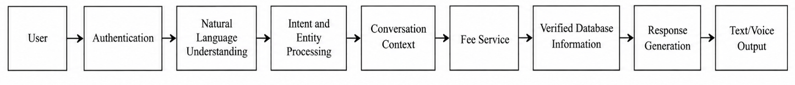
This separation is central to the design of the proposed system. It allows the flexibility of conversational interaction without sacrificing the reliability of structured data processing.

1.10 Contributions of the Project
The project offers a way to talk about personal educational fee information. Of using chatbots as just a general way to answer questions FeeAssist AI uses language understanding with a set information area and user data that is confirmed. One part of the work is connecting machine learning intent recognition with a personal database system. The system goes beyond knowing what a question means. It uses the intent to pick the right fee action and get info for the student who is logged in. Another part is making the chat part work in than one language. Questions in English, Hindi and Marathi are connected to the fee-related goals. This lets the same rules work for people who speak languages.

A third part is keeping the way the language is understood separate from the money calculations. The machine learning part handles what the user is asking. The fee service does the work of getting and calculating the money details. This way the system does not rely on models that generate text for money numbers. A fourth part is using a way to handle when the AI is not sure. When the system is not confident or the question is tricky it uses Gemini as a back-up, not the way to get answers. This makes sure the system is predictable but also can handle complex questions.

A fifth part is adding the conversation history into the fee process. The system is built to handle questions after the first one not just see each message as a new request. A sixth part is adding the ability to talk of type. Voice. Output work with the same chat system. This keeps the language processing, login and fee processes. At the end the project brings together React for the end FastAPI for the back end PostgreSQL, for the data machine learning, NLP steps, login, controlled AI for answers and voice tools into one complete app.

1.11 Organization of the Report
In the following sections I will show how FeeAssist AI was built starting from the problem area and current methods moving through design, methods, building and testing.

Chapter 2: Literature Review looks at research and tech progress about chat systems, Natural Language Processing, machine learning text sorting speaking in languages and personalized data services. I compare tools to spot where new work is needed and show how FeeAssist AI fills that gap.

Chapter 3: Existing System and Problem Analysis explains the ways students look up their fees and points out how these methods work, where they fail and what problems arise. I lay out what users need what the system must do what it should not do how realistic the project is and how FeeAssist AI solves these issues.

Chapter 4: System Analysis and Design shows the plan for FeeAssist AI. I detail the system layout, how data moves, the main parts, diagrams, example scenarios, step-by-step actions, interactions, data organization and how we keep information safe.

Chapter 5: Technologies and Tools Used talks about the computers and software I used and why I chose each one. I cover the languages, frameworks, libraries, APIs, database tools, coding utilities and how I manage versions and explain the logic behind each choice.

Chapter 6: Proposed Methodology describes how I built the Natural Language Processing and machine learning parts of FeeAssist AI. I walk through gathering data cleaning it creating features picking algorithms, building models, training, checking performance using metrics writing sample code and showing the whole process step, by step.

Chapter 7: System Implementation shows the build of FeeAssist AI. I explain the modules, how the database works, the user interface, the server side connecting to APIs dealing with errors signing in keeping data safe and the full working flow.

Chapter 8: Results and Discussion looks at the system that was built. It shows how the experiments were set up lists the test cases and covers both tests and performance tests. It also shares the results of the machine learning evaluation includes graphs compares the method to the old one and gives a thorough discussion of what was found and the limits of the system.

Chapter 9: Conclusion and Future Scope wraps up the work that has been finished. It talks about the discoveries checks whether the project goals were met and lays out how the system can be used what could be improved, the paths, for future development and the final take-away.

CHAPTER 2
LITERATURE REVIEW

2.1 Introduction
Natural Language Processing (NLP) and Artificial Intelligence have enabled software systems to understand and respond to users through natural language. Conversational systems are increasingly used in education, banking, customer support, and other information-based services. In the educational domain, chatbots have been studied for providing academic assistance, answering frequently asked questions, and supporting students with institutional information.

For a personalized fee-assistance system, however, simple question answering is not sufficient. The system must understand the student's intention, identify relevant information from the query, authenticate the user, retrieve the correct fee records, and provide an accurate response. Research on task-oriented dialogue systems identifies intent classification and entity extraction as important components of Natural Language Understanding. These concepts form the foundation of the FeeAssist AI system.

The proposed system further extends this approach by combining NLP with personalized student data, multilingual interaction, conversation context, deterministic fee calculations, and optional voice interaction.

2.2 Existing Research in the Problem Domain
Research in task-oriented conversational systems has mainly focused on understanding what a user wants and extracting important information from the user's query. Intent classification determines the purpose of a query, while entity or slot extraction identifies specific values such as amounts, dates, locations, or identifiers.

For example, in the query "How much fee do I have left for Semester 5?", the intent can be identified as a pending-fee query, while "Semester 5" represents an entity that can help identify the appropriate fee record.

Educational chatbot research has demonstrated that conversational systems can provide useful student support. However, many educational chatbots primarily provide common or static institutional information. Personalized questions require access to authenticated student-specific records.

Multilingual NLP is another important research area. Existing studies have demonstrated intent detection across multiple languages and have also explored lower-resource languages. This is relevant to FeeAssist AI because the proposed system supports English, Hindi, and Marathi, while maintaining the same underlying fee-management operations. Research in financial conversational systems also provides useful guidance because financial queries require domain-specific intent recognition and reliable access to structured information. This principle is applied to student fee management in the proposed system.
2.3 Review of Existing Systems
Existing systems related to the proposed project can broadly be classified into traditional fee-management systems, educational FAQ chatbots, general-purpose AI assistants, and domain-specific conversational systems.

Traditional fee-management systems generally provide information through dashboards, forms, tables, and predefined navigation. They are effective for storing and displaying structured records but provide limited natural-language interaction.

Educational FAQ chatbots allow students to ask questions conversationally, but they generally work with common institutional information. They may not have access to individual payment history, scholarship information, pending fees, or due dates.

General-purpose generative AI assistants provide flexible natural-language interaction but cannot automatically be considered an authoritative source for personalized financial information. Without connection to verified records, a generated response may not represent the actual student's financial status.

FeeAssist AI combines the strengths of these approaches by providing a conversational interface while using authenticated student records as the source of personalized fee information.

2.4 Review of Existing Technologies
Several technologies are combined to develop the proposed system.
Natural Language Processing is used to preprocess user queries and understand their meaning. The system uses TF-IDF to convert textual queries into numerical feature representations suitable for machine learning.

For intent classification, algorithms such as Multinomial Naive Bayes, Logistic Regression, and Support Vector Machine (SVM) are evaluated. The final model is selected using the actual experimental results obtained from the project's dataset. Entity extraction is used to identify information such as amounts, dates, semesters, academic years, fee types, payment methods, and transaction identifiers. Conversation context is maintained to support follow-up questions.

PostgreSQL is used to store users, fee records, payments, conversations, and messages. FastAPI provides the backend API layer, while React with Vite and JavaScript is used to develop the frontend.
Authentication is implemented using JWT, ensuring that fee information is retrieved only for the authenticated student. Gemini is included as a controlled fallback for low-confidence or complex queries, while verified database information and the Fee Service remain the source of truth for financial values. Optional Speech-to-Text and Text-to-Speech technologies provide voice interaction using the same underlying NLP and fee-processing pipeline.

2.5 Comparative Analysis of Existing Approaches
The major differences between existing approaches and the proposed system are summarized below.

Table I : Comparative Analysis of Existing Approaches
System / Approach | Natural Language | Multilingual
Traditional Fee System | Limited | Limited
FAQ Educational Chatbot | Yes | Depends on system
General AI Assistant | Yes | Yes
Financial Chatbot | Yes | Depends on system
FeeAssist AI | Yes | English, Hindi, Marathi

The comparison shows that traditional systems focus mainly on structured information management, whereas conversational systems focus on natural-language interaction. FeeAssist AI combines these approaches by using NLP for understanding and a verified database with business logic for personalized fee information.

2.6 Research/Technology Gap
The literature shows that the individual technologies required for conversational fee assistance already exist. Intent classification, entity extraction, multilingual NLP, educational chatbots, financial conversational systems, and generative AI have all been studied independently.

However, there is a need for an integrated system specifically designed for personalized student fee assistance. A conventional fee system provides structured and reliable information but generally requires manual navigation. A general chatbot provides conversational interaction but may not have access to authenticated student records. A generative AI system can understand flexible language but should not independently generate personalized financial values.

FeeAssist AI addresses this gap by combining these capabilities in a single architecture. The NLP model identifies the user's intent, entity processing extracts relevant information, conversation context handles follow-up questions, authentication identifies the student, and the Fee Service retrieves verified records and performs the required calculations.

The system also introduces multilingual interaction in English, Hindi, and Marathi and provides controlled use of Gemini for cases where the primary NLP classifier requires additional language assistance.

2.7 Limitations of Existing Systems
Existing systems have several limitations that are relevant to the proposed project. Traditional fee-management applications generally depend on structured interfaces and require users to navigate through multiple screens. FAQ chatbots may provide institutional information but cannot easily answer questions that depend on individual student records.

Multilingual conversational systems also face challenges related to language resources, training data, and differences between languages. Voice-based systems introduce additional challenges because speech-recognition errors can affect subsequent language processing.

Another important limitation is the reliability of generative AI for financial information. Although generative models can produce natural and meaningful responses, they should not be treated as the authoritative source for personalized fee amounts or payment information. Such values must be obtained from verified records.

Finally, machine learning-based intent classification depends on the quality and coverage of the training dataset. Similar queries belonging to different intents may sometimes be difficult to distinguish. Therefore, dataset preparation, model evaluation, and appropriate fallback handling are necessary.

2.8 Summary of Literature Review
The literature review demonstrates that NLP, machine learning, multilingual processing, educational chatbots, and conversational AI provide a strong foundation for developing intelligent student-support systems. Research on task-oriented dialogue particularly establishes the importance of intent classification and entity extraction for understanding user requirements.
Existing fee-management systems provide reliable structured information but generally lack natural conversational interaction, while general conversational systems may lack access to personalized and verified student data. These limitations create an opportunity for a system that combines conversational interaction with authenticated database access.

FeeAssist AI addresses this requirement through a layered approach in which NLP understands the user's request, the authentication layer identifies the student, the Fee Service retrieves and calculates verified information, and the response layer communicates the result in the user's preferred language. Multilingual support, conversation context, controlled Gemini assistance, and optional voice interaction further extend the capabilities of the system.

CHAPTER 3
EXISTING SYSTEM AND PROBLEM ANALYSIS

3.1 Introduction
The analysis of an existing system is an important step in the development of any software application because it helps identify the limitations of current practices and provides a clear foundation for designing an improved solution. In the context of student fee management, educational institutions generally use conventional fee-management applications, student portals, office-based records, or a combination of these approaches to maintain information related to fees, payments, scholarships, receipts, and due dates. These systems are useful for maintaining structured records, but interaction with the stored information is generally dependent on predefined screens, forms, menus, and reports.

Students frequently need answers to questions such as how much fee is pending, whether a payment has been recorded, when the next payment is due, how a scholarship affects the payable amount, or whether the remaining fee can be paid through installments. In a conventional system, obtaining such information may require the student to log in, navigate to a particular section, locate the appropriate academic year or semester, and manually interpret the displayed information. When the student asks a follow-up question, the process may have to be repeated.

The problem becomes more significant when students use natural language rather than structured interfaces. A question such as “I paid ₹10,000 yesterday, so how much do I have left now?” contains an action, an amount, a date reference, and an implicit request for a calculation. A conventional fee-management system does not normally interpret such a query. Therefore, there is a requirement for a system that combines reliable fee-data management with natural-language interaction.
This chapter examines the existing approach, identifies the major problems faced by students, defines the functional and non-functional requirements of the proposed system, evaluates its feasibility, and introduces the proposed FeeAssist AI system.

3.2 Existing System
The existing approach to student fee management is primarily based on structured data entry and information retrieval. Student information, fee structures, payment details, scholarship information, and related records are generally maintained in institutional databases or fee-management software. Students access the information through a web portal, mobile application, administrative office, or other predefined interface depending on the institution.

A typical system provides separate sections for viewing fee details, making or recording payments, checking transaction history, downloading receipts, and viewing outstanding amounts. The information is generally organized according to academic year, semester, course, fee category, or payment transaction. This structure is suitable for storing and presenting financial information in an organized manner.

However, the interaction model is largely interface-driven rather than conversation-driven. The student must know which section contains the required information and must provide or select the required values using predefined controls. For example, to determine the remaining fee, the student may need to open the fee details page, identify the total fee, check the amount already paid, consider any applicable scholarship, and then determine the outstanding amount.

The existing system also generally treats each operation independently. A student may check a payment record and then separately check the pending amount. The system does not necessarily understand that a follow-up query such as “What about after I pay another ₹5,000?” is related to the previous conversation.

Another limitation is that conventional fee-management applications are generally designed around structured information rather than natural-language understanding. They can store the values entered into a database, but they do not necessarily classify the intention behind a student's question. Consequently, a student cannot always communicate with the system in the same way they would communicate with a human administrator.

3.3 Working of Existing System
The working of a conventional student fee-management system can be understood as a sequence of user-interface and database operations. First, the student accesses the institutional fee-management system using an account or other identification mechanism. After authentication, the system displays information associated with the student's account. The student then selects the required section, such as fee details, payment history, scholarship information, or receipts.

When the student wants to check the fee structure, the system retrieves the corresponding fee record from the database and displays the stored values. Similarly, when the student wants to check payment information, the system retrieves the relevant payment records and presents information such as payment amount, payment date, transaction identifier, or payment status.

For example, consider a student whose fee record contains a total fee of ₹80,000, a paid amount of ₹30,000, and a scholarship amount of ₹20,000. The outstanding amount can be calculated as:

Remaining Fee = Total Fee - Paid Amount - Scholarship Amount

Substituting the values:
$$\text{Remaining Fee}=\text{₹}80,000-\text{₹}30,000-\text{₹}20,000$$
In a conventional application, this value may either be calculated by the application and displayed as a field or require the user to interpret the available values. The system generally performs the operation based on structured fields rather than understanding a natural-language question.

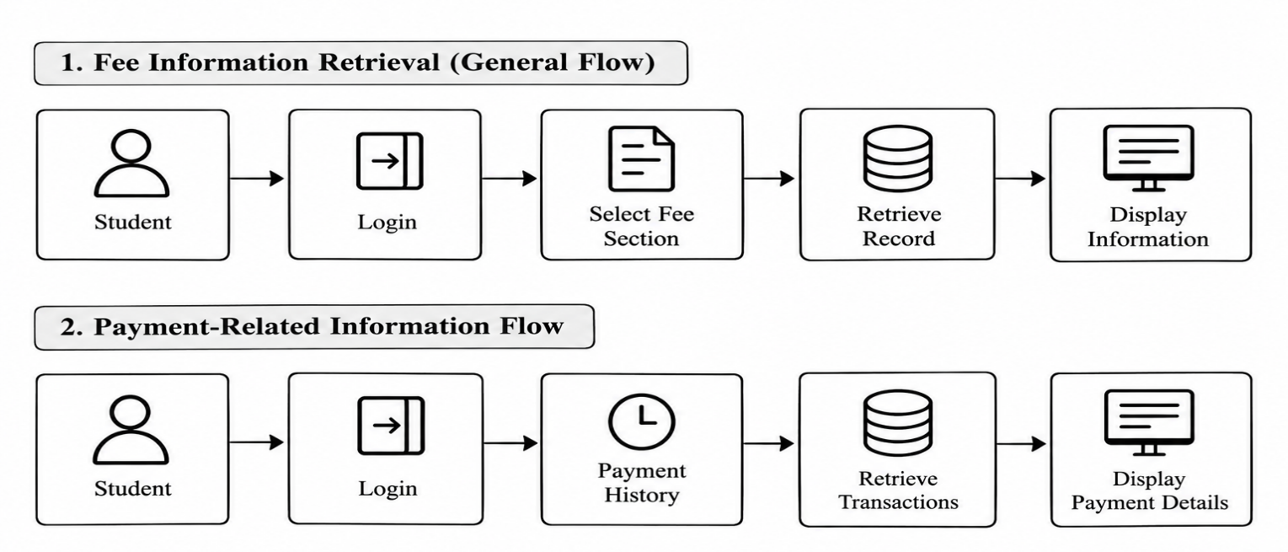
3.4 Limitations of Existing System
The analysis of the existing approach identifies several limitations that affect the convenience and intelligence of student fee management.
Lack of Natural Language Understanding : Traditional fee-management systems primarily operate on structured inputs. They do not generally understand queries such as “How much do I still need to pay?” or “I paid ₹10,000 today; what is my new balance?” as natural-language requests.
Limited Personalization : Although existing systems store individual student records, their interaction with those records is generally limited to displaying predefined information. The system does not necessarily interpret the student's question and dynamically select the appropriate personalized information.
Difficulty with Follow-Up Questions : A conventional system generally treats each operation as a separate request. It does not maintain conversational context in the same manner as a conversational assistant. As a result, questions that depend on previous messages may require the student to repeat information.
Difficulty Handling Different Fee Records : A student may have multiple fee records corresponding to different academic years or semesters. If a query does not clearly identify the required record, a system should determine the appropriate record or ask for clarification. Conventional interfaces generally require the student to manually select the appropriate record.

3.5 Problems Identified
The analysis of the existing system reveals that the primary problem is not the absence of fee information but the difficulty of accessing and understanding that information through a natural and personalized interaction.
The problem is the lack of intent-based understanding. Different questions may express the same requirement. For example, “How much fee is left?”, “What is my pending fee?”, and “How much do I still need to pay?” have different wording but can represent the same pending-fee intent. A useful assistant must identify the underlying intention rather than depend only on exact keywords.

The problem is personalized information retrieval. A response concerning fee status must be associated with the authenticated student. The system cannot simply provide a general answer because fee amounts, payments, scholarships, and due dates vary between students.

The problem is contextual interaction. Students frequently ask follow-up questions without repeating all the information from the previous message. A conversational system therefore needs to retain relevant context so that subsequent questions can be interpreted correctly.

The problem is reliable financial calculation. Financial values such as remaining fees should not be generated merely as natural-language predictions. They must be calculated using verified student records and deterministic business rules. This establishes a clear separation between language understanding and financial computation.

3.6 User Requirements
The requirements of FeeAssist AI are derived from the problems identified in the existing system. The system is primarily intended for students who need convenient access to their own fee information through natural-language interaction.

The system requires secure user authentication so that each student has an individual account and can access only their own fee and payment records. It provides a My Fees facility where students can create and manage records including academic year, semester, course, total fee, paid amount, scholarship amount, and due date, while the remaining fee is calculated automatically by the system. The system also supports natural-language querying, allowing students to ask fee-related questions in ordinary language without knowing the database structure, and provides personalized responses based on the authenticated student's records. It supports English, Hindi, and Marathi for multilingual interaction and maintains conversation context to understand relevant follow-up questions. Financial calculations are performed by the business-logic layer using verified database values, while the NLP model is responsible only for identifying user intent. Additionally, the system may provide optional voice interaction through Speech-to-Text and Text-to-Speech technologies, allowing students to submit spoken queries and receive spoken responses.

3.7 Functional Requirements
Functional requirements describe the operations that the system must perform.

User Registration and Authentication : The system shall allow students to create an account and securely log in. Authentication shall be implemented using secure password storage and JWT-based session authorization.

User Profile Management : The system shall maintain basic student information such as name, email, course, academic year, semester, and preferred language where applicable.

Fee Record Management : The system shall allow an authenticated student to create, view, update, and delete fee records. Each record may contain academic year, semester, course, total fee, paid amount, scholarship amount, due date, fee category, and notes.
Automatic Remaining-Fee Calculation

The system shall calculate the remaining fee using:
[ R = T - P – S ]
Where : R - Remaining Fee
T - Total Fee
P - Paid Amount
S - Scholarship Amount
The calculation shall be performed by the backend business-logic layer.

Payment Management : The system shall store and display payment details such as payment amount, date, method, transaction ID, fee type, and payment status.

Natural-Language Query Processing : The system shall accept fee-related queries in natural language and process them using intent classification and entity extraction. Supported intents shall include fee structure, pending fee, payment status, payment history, due date, installments, scholarship, refund, receipt, and other fee-related queries. The system shall identify relevant entities such as amounts, dates, semesters, academic years, fee categories, payment methods, transaction IDs, and installment counts.

Conversation and Multilingual Processing : The system shall maintain relevant conversation context to understand follow-up questions and shall support fee-related queries in English, Hindi, and Marathi by mapping them to the appropriate underlying intent.

Personalized Fee Retrieval : The system shall retrieve fee and payment information using the authenticated student's identity. The frontend shall not be allowed to provide arbitrary user identifiers for accessing another student's records.

Controlled AI and Voice Support : For low-confidence or complex queries, the system may use Gemini as a secondary language-processing mechanism, while verified database records and business-logic calculations shall remain authoritative. The system may also support optional Speech-to-Text and Text-to-Speech interaction using the same intent, context, and fee-processing pipeline.

Error and Missing-Data Handling : The system shall provide meaningful responses when required fee or payment records are unavailable. It shall not generate or assume missing financial values and shall guide the student to the appropriate section, such as My Fees, when a required record does not exist.

3.8 Non-Functional Requirements
Non-functional requirements describe the quality characteristics and operational constraints of the proposed system.
Security and Privacy : The system shall protect student authentication credentials and financial information through secure password hashing, authenticated API access, and restricted database queries. Student fee and payment data shall be accessible only to authorized users and shall not be unnecessarily exposed through logs, client-side storage, or external AI services.
Accuracy and Reliability : Financial calculations shall be deterministic and based on verified database records. The NLP model shall be evaluated using appropriate performance metrics before deployment. The core text-based fee assistance shall continue to function even when optional services such as voice processing or Gemini are unavailable.

Usability and Responsiveness : The interface shall be simple and easy for students to use without extensive training. Important features such as My Fees, payment history, and chat shall be easily accessible, and the system shall provide clear feedback during operations such as data retrieval, chat processing, and voice processing.

Maintainability and Scalability : The system shall use modular components for authentication, NLP, fee processing, conversation management, database operations, and voice services. The architecture shall support increasing numbers of users, records, intents, languages, and services without requiring a complete redesign.

Portability and Extensibility : The application shall support different development and deployment environments through Docker and Docker Compose. The architecture shall also allow future additions such as new fee-related intents, Indian languages, improved NLP models, institutional policies, and additional communication channels.

3.9 Feasibility Study
A feasibility study determines whether the proposed FeeAssist AI system can be developed and operated using available technical, financial, and operational resources. The feasibility of the system is evaluated in terms of technical, economic, and operational aspects.

Technical Feasibility : FeeAssist AI is technically feasible because it uses established technologies that can be integrated through a modular architecture. React, Vite, JavaScript, and Tailwind CSS can be used for the frontend, while Python and FastAPI can handle backend operations. NLP and machine learning can be implemented using NLTK, spaCy, pandas, NumPy, and scikit-learn with TF-IDF and suitable classification algorithms. PostgreSQL provides the required database, while Docker simplifies deployment and environment management. JWT supports secure authentication, and Gemini and voice services can be integrated as optional components.

Economic Feasibility : The system is economically feasible because most of its core technologies are open-source and do not require expensive software licenses. The application can be developed using a standard personal or laboratory computer, with PostgreSQL running through Docker. External AI and voice services may involve usage-based costs, but they are not essential for the core fee-management and NLP functionality. Therefore, the overall development cost can be kept relatively low.

Operational Feasibility : FeeAssist AI is operationally feasible because it is designed around common student requirements such as checking pending fees, payment history, due dates, and scholarship information. Students can use the system through a simple graphical interface and natural-language queries without requiring technical knowledge. The My Fees module provides structured fee management, while the conversational interface simplifies information retrieval

3.10 Proposed System
The proposed system, FeeAssist AI, is a personalized multilingual and voice-enabled fee query assistant that combines NLP, machine learning, authenticated database access, and deterministic fee calculations. Students can securely log in, manage their fee records through My Fees, and ask questions about their fees using natural language. The system uses intent classification, entity extraction, and conversation context to understand queries and follow-up questions.

The Fee Service retrieves verified student data from PostgreSQL and performs fee-related calculations. Gemini may be used as a controlled fallback for low-confidence or complex queries, but verified database records remain the source of financial information. The system supports English, Hindi, and Marathi, while optional voice interaction provides Speech-to-Text and Text-to-Speech capabilities using the same processing pipeline.

3.11 Advantages of Proposed System
FeeAssist AI provides a convenient and personalized approach to student fee management by allowing students to ask questions using natural language and receive responses based on their authenticated fee records. It automatically calculates the remaining fee, supports English, Hindi, and Marathi, and maintains conversation context for follow-up queries. JWT-based authentication provides user-level data isolation, while Gemini is used only as a controlled secondary assistance mechanism. Optional voice interaction improves accessibility, and the modular architecture makes the system easier to maintain and extend. The separation between NLP-based intent understanding and the Fee Service's verified financial calculations also improves the reliability and traceability of personalized fee responses.

CHAPTER 4
SYSTEM ANALYSIS AND DESIGN
4.1 Introduction
System analysis and design defines the structure, components, data flow, and interaction of the proposed FeeAssist AI system. This chapter describes how the different modules work together to provide secure, personalized, multilingual fee assistance. The design separates natural-language understanding from financial processing so that the machine learning model identifies the user's intent while the Fee Service retrieves verified data and performs fee-related calculations.

4.2 System Architecture
FeeAssist AI follows a layered architecture consisting of the user interface, authentication, Natural Language Processing, conversation management, Fee Service, database, and optional AI and voice services. The frontend is developed using React and communicates with the FastAPI backend through APIs. After authentication, the user's query is processed through language detection, preprocessing, intent classification, entity extraction, and conversation context. The Fee Service then retrieves the authenticated student's information from PostgreSQL and performs the required business calculations. Gemini is used only as a controlled fallback for selected low-confidence or complex queries.

4.3 Overall System Workflow
The overall workflow begins when a student registers or logs into the system. After authentication, the student can create and manage fee records through the My Fees module. When a student submits a query, the system detects the language, preprocesses the text, identifies the intent, extracts relevant entities, and considers conversation context. The request is then passed to the Fee Service, which retrieves the appropriate authenticated student's data and performs any required calculation. The final response is returned through the chat interface or optional voice output.

4.4 Module Identification
The proposed system is divided into the following major modules:

- User Authentication and Profile Module
- My Fees and Fee Management Module
- NLP and Intent Classification Module
- Entity and Conversation Management Module
- Fee Service Module
- Multilingual Processing Module
- Controlled Gemini Fallback Module
- Voice Interaction Module
- Database Management Module

These modules are separated according to their responsibilities so that each part of the system can be developed, tested, and maintained independently.

4.5 Module Description
User Authentication and Profile Module : This module manages user registration, login, password security, JWT authentication, and profile information. It ensures that personalized fee information is accessible only to the authenticated student
.
My Fees and Fee Management Module : The My Fees module allows students to create, view, update, and delete their fee records. It stores information such as academic year, semester, total fee, paid amount, scholarship, and due date. The remaining fee is calculated automatically by the backend.

NLP and Intent Classification Module : This module processes natural-language queries and identifies the user's intention. TF-IDF is used for feature representation, while machine learning algorithms such as Naive Bayes, Logistic Regression, and SVM can be evaluated for classification.

Entity and Conversation Management Module : This module extracts relevant information such as amounts, dates, semesters, academic years, fee types, payment methods, and transaction identifiers. It also maintains relevant conversation context to support follow-up questions.

Fee Service Module : The Fee Service acts as the main business-logic layer for fee-related operations. It retrieves verified student records and performs operations such as pending-fee calculation, payment-status checking, payment-history retrieval, due-date checking, scholarship information, installment information, refund information, and receipt information.

Multilingual Processing Module : This module supports English, Hindi, and Marathi queries. The language of the current query is considered first, followed by conversation and user preferences when required. The underlying intent and fee-processing logic remain common across supported languages.

Controlled Gemini Fallback Module : Gemini provides secondary language assistance when the primary NLP system has low confidence or encounters a supported complex query. It does not act as the source of financial information. Verified fee and payment information is obtained from the application's database and Fee Service.

Voice Interaction Module : The voice module provides optional Speech-to-Text and Text-to-Speech functionality. A spoken query is converted into text and passed through the same NLP and fee-processing pipeline used for normal text queries.

Database Management Module : PostgreSQL stores users, fee records, payments, conversations, and messages. The database runs inside Docker and uses persistent storage so that application data remains available between container restarts.

4.6 Data Flow Diagram

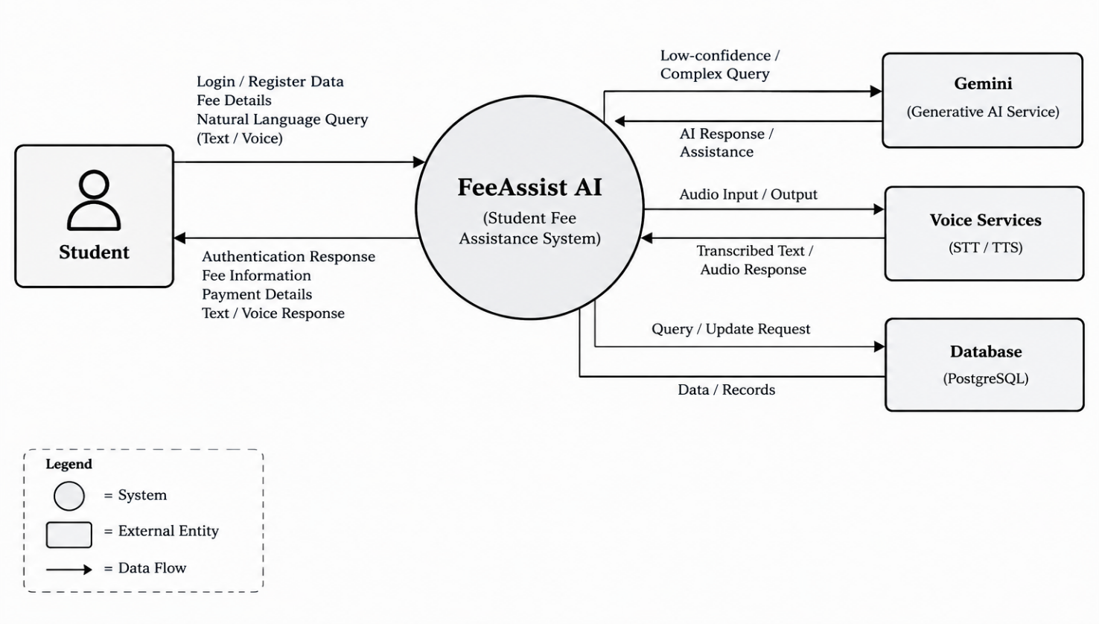
4.6.1 Context-Level DFD

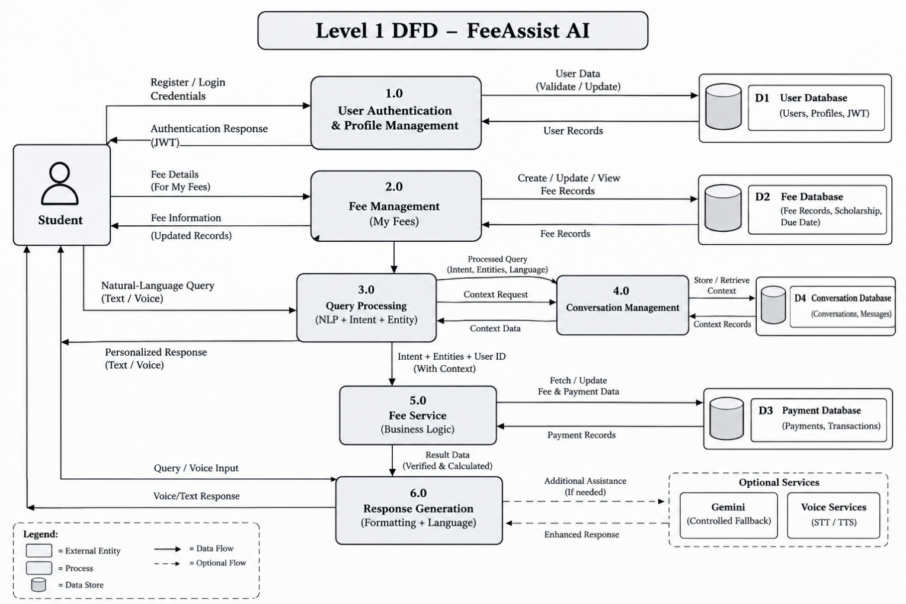
4.6.2 Level-1 DFD
4.6.3 Level-2 DFD

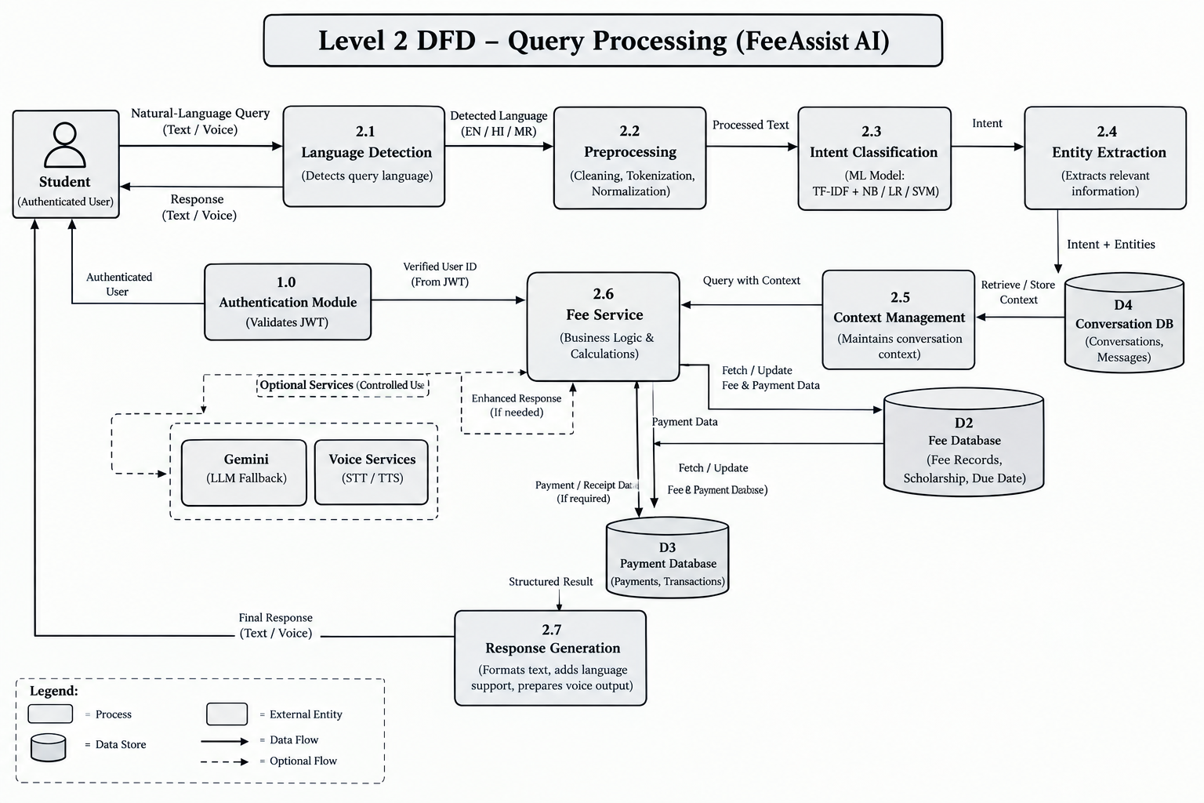

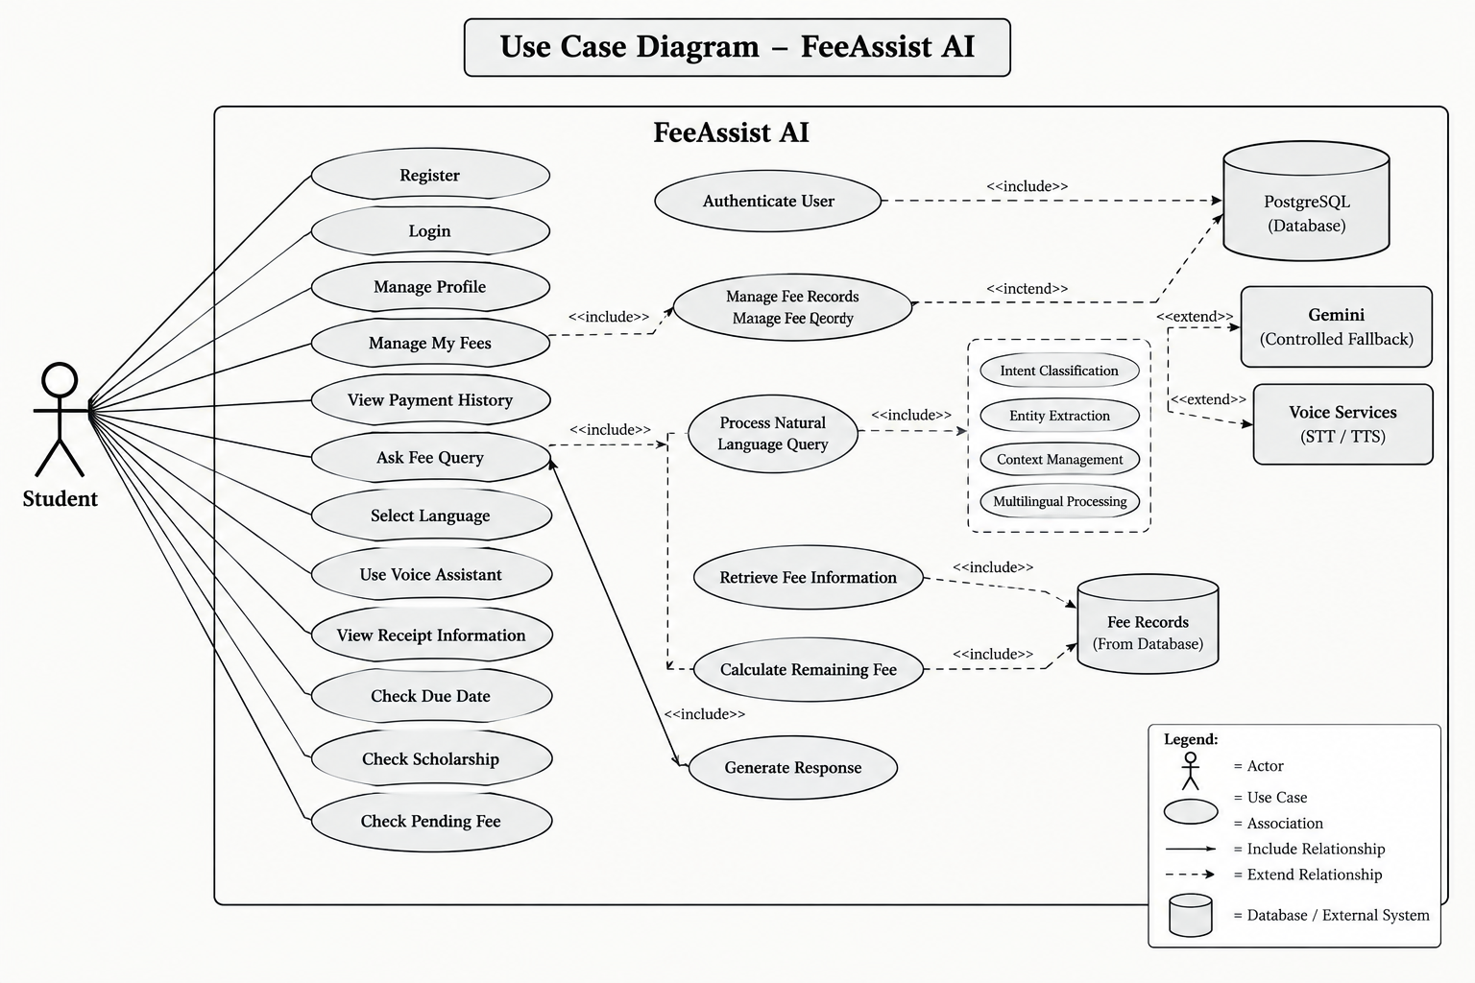
4.7 Use Case Diagram

4.8 Activity Diagram
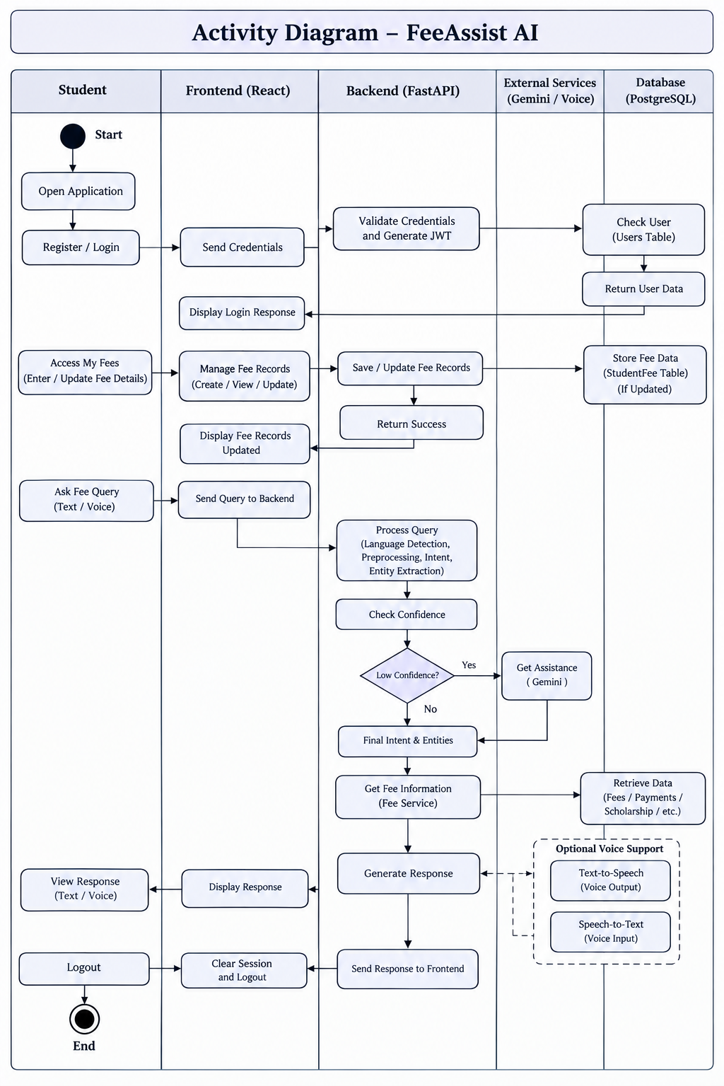

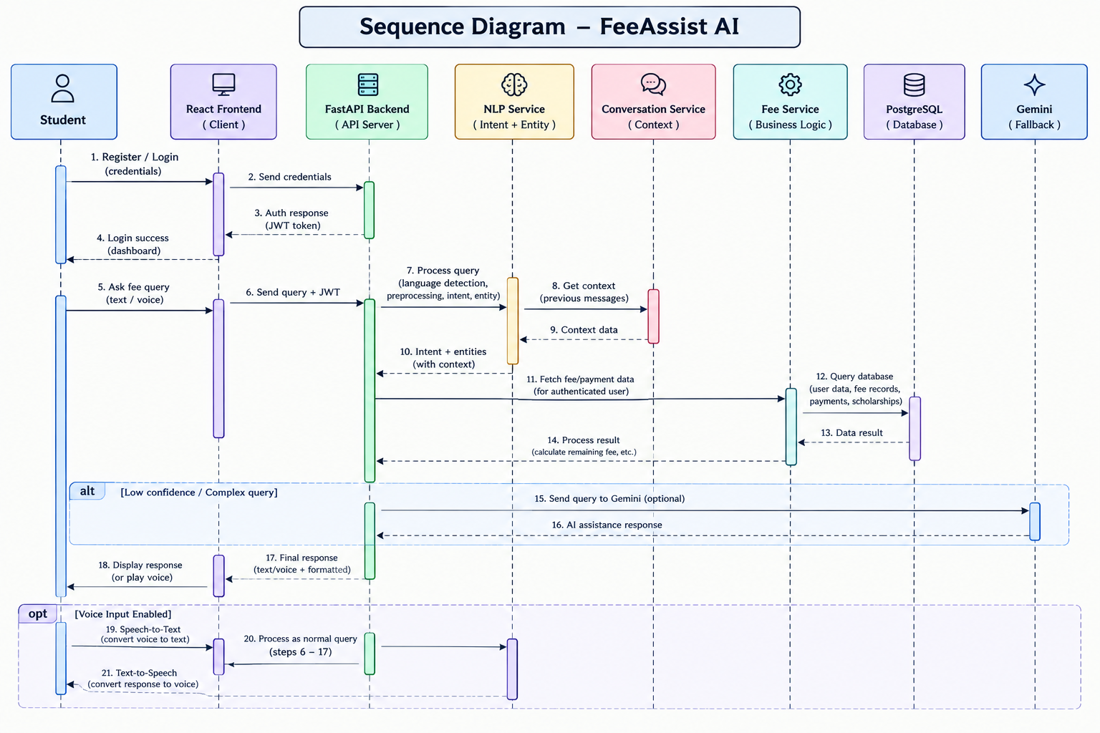
4.9 Class Sequence Diagram

4.10 Class Diagram
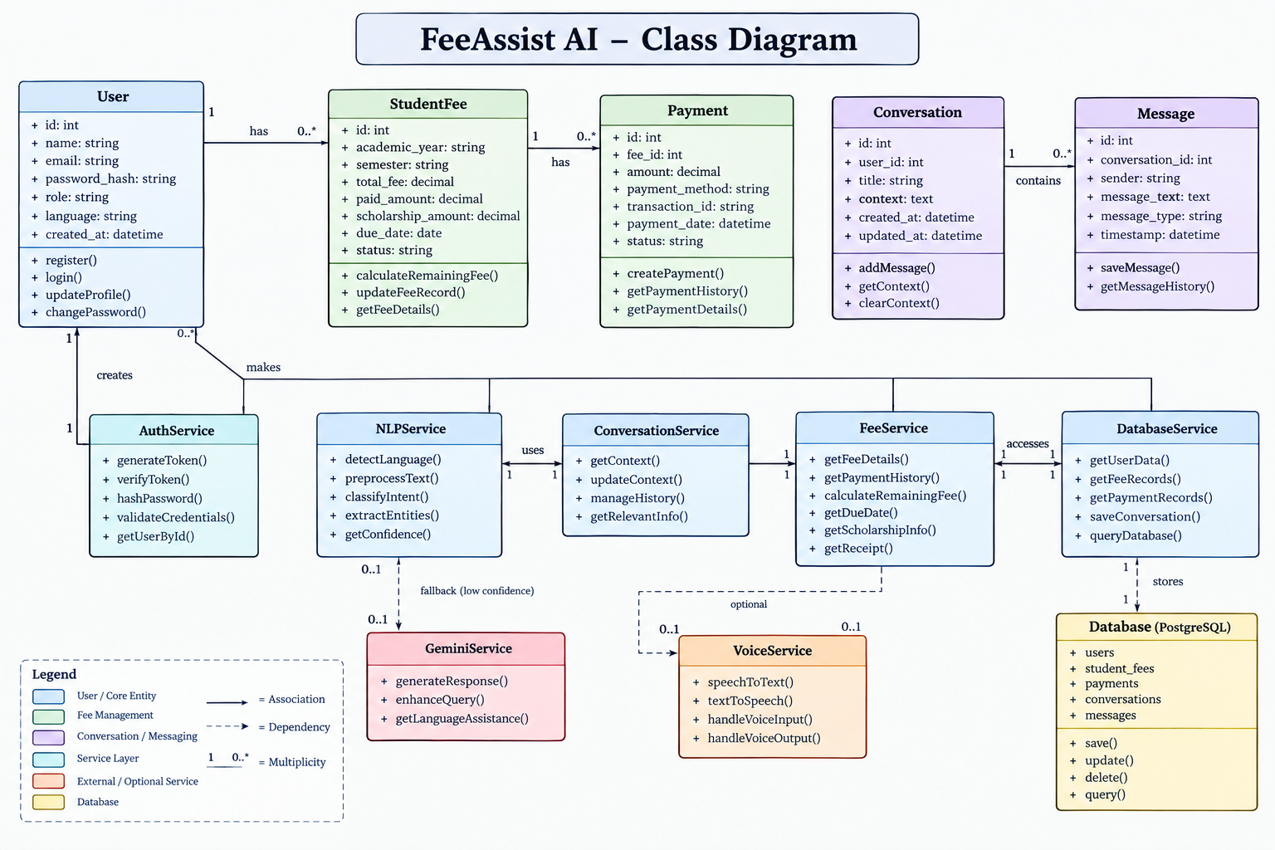

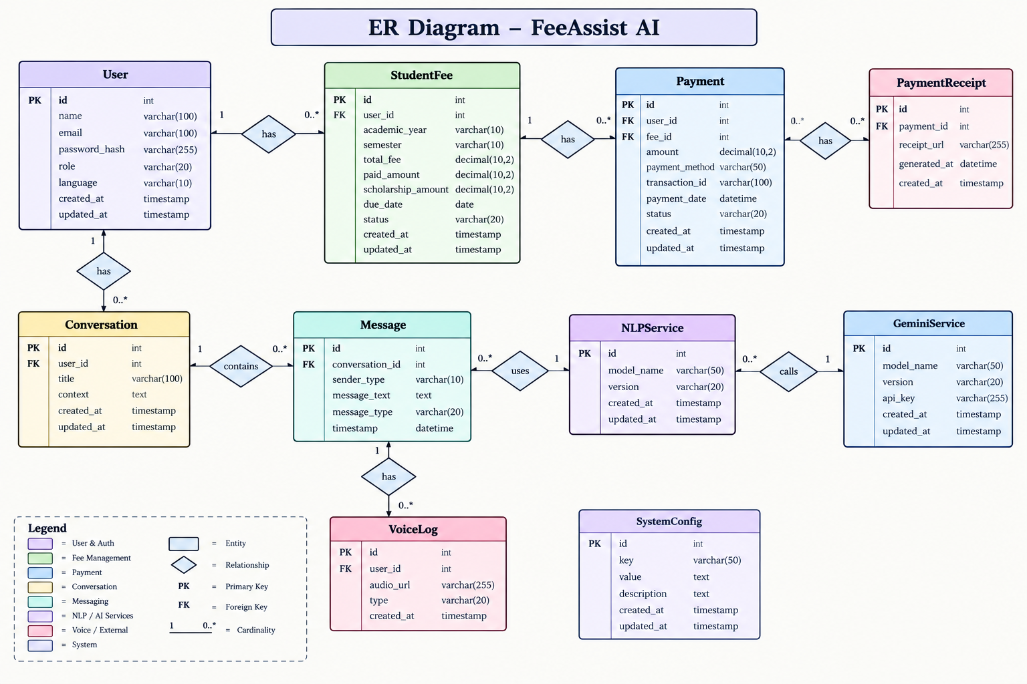
4.11 ER Diagram

4.12 Data Flow and Processing
The data flow in FeeAssist AI describes how information moves from the student to the application and back to the student. After authentication, the student's identity is verified using JWT, and the system provides access to the student's own fee records. When a query is submitted, the system detects the language, preprocesses the text, identifies the intent, and extracts relevant entities such as amount, date, semester, or academic year. The conversation context is then considered for follow-up questions.
The processed request is passed to the Fee Service, which retrieves the required information from PostgreSQL using the authenticated user's identity. If a calculation is required, such as determining the remaining fee, it is performed using the stored values and predefined business rules. The verified result is then converted into a natural-language response and returned through the chat interface or optional voice output.
The overall data flow can be represented as:
$$\text{User Query}→\text{Language Detection}→\text{Preprocessing}→\text{Intent Classification}→\text{Entity Extraction}→\text{Conversation Context}→\text{Fee Service}→\text{PostgreSQL}→\text{Business Logic}→\text{Response}$$
For example, if a student asks “How much fee do I have left?”, the NLP module identifies the query as a pending-fee request. The Fee Service retrieves the student's fee record and calculates the remaining amount using:
$$\text{Remaining Fee}=\text{Total Fee}-\text{Paid Amount}-\text{Scholarship Amount}$$
The calculated value is then included in the final response. This separation ensures that the NLP model understands the query while the Fee Service remains responsible for retrieving and calculating verified financial information.
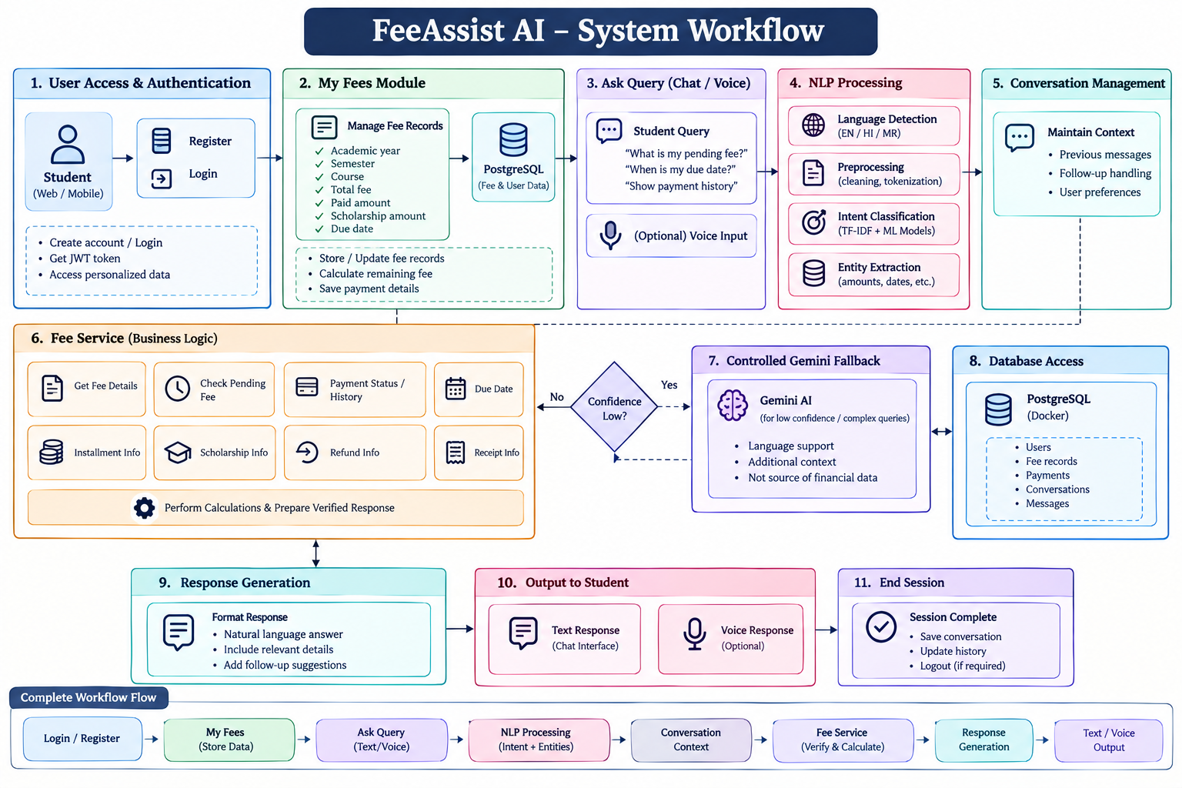
4.13 System Workflow

4.14 Security and Privacy Considerations
Security and privacy are important in FeeAssist AI because the system handles student accounts, fee records, payment information, and conversation data. The system uses JWT-based authentication and secure password hashing to protect user accounts, while backend-level authorization ensures that students can access only their own records. Sensitive information such as payment details, transaction identifiers, and student data should not be unnecessarily stored in logs, and API keys must be protected using environment variables. Gemini is used in a controlled manner, with only the minimum required context shared, while financial information such as fee amounts, payment status, due dates, and scholarship details is retrieved from verified PostgreSQL records through the Fee Service. Secure communication, input validation, proper error handling, and database access controls further reduce the risk of unauthorized access. Thus, authentication verifies the user, authorization controls access to personal data, and the database and Fee Service remain the trusted sources for personalized financial information.
CHAPTER 5
TECHNOLOGIES AND TOOLS USED

5.1 Introduction
This chapter documents the technology stack, hardware and software environment, and development tools used to build FeeAssist AI. The stack was chosen to support rapid full-stack development, dependable natural-language processing on modest hardware, and containerised deployment, while keeping the majority of components open-source and free of licensing cost.

5.2 Hardware Requirements
The application was developed and evaluated on standard developer hardware; no specialised GPU or high-memory server was required because the NLP pipeline relies on classical machine learning rather than deep neural networks.
Table II : Hardware Requirements

Component | Minimum | Used for Development
Processor | Dual-core, 2.0 GHz | Quad-core, 2.6 GHz
RAM | 4 GB | 8 - 16 GB
Storage | 5 GB free space | SSD, 20 GB free space
Network | Broadband internet (for Gemini/voice APIs) | Broadband internet

5.3 Software Requirements
Table III : Software Requirements
Category | Software / Version
Operating System | Windows 10/11, Ubuntu 22.04 (cross-platform)
Backend Runtime | Python 3.10+
Frontend Runtime | Node.js 18+
Database | PostgreSQL 15
Containerisation | Docker, Docker Compose
IDE | Visual Studio Code
API Testing | Postman

5.4 Programming Languages
Python is used for the backend, the NLP/ML pipeline and data preprocessing scripts because of its mature ecosystem of natural-language and machine-learning libraries. JavaScript (with JSX) is used for the frontend, giving direct access to the React component model and the wider npm ecosystem for UI, voice and HTTP-client libraries.

5.5 Development Frameworks
FastAPI builds the backend REST API. It was chosen over Flask and Django for automatic request validation through Pydantic, native async handling, and auto-generated OpenAPI documentation, reducing boilerplate. React, scaffolded with Vite, is used for the frontend for its component-based structure and fast hot-reload loop. Tailwind CSS handles styling, letting the interface be built quickly with utility classes rather than a large separate stylesheet.

5.6 Libraries and APIs
Table IV : Libraries and APIs Used
Library / API | Role in the System
NLTK | Tokenisation, stop-word removal, stemming for English text
spaCy | Lemmatisation and rule-assisted entity extraction
scikit-learn | TF-IDF vectorisation, model training and evaluation
pandas / NumPy | Dataset handling and numerical preprocessing
SQLAlchemy | ORM layer between FastAPI and PostgreSQL
PyJWT / passlib | Token issuing/verification and password hashing
Gemini API | Secondary language assistance (fallback only)
Web Speech API / gTTS | Speech-to-text input and text-to-speech output for voice mode

5.7 Database Technologies
PostgreSQL was selected as the primary data store for its strong relational integrity, mature constraint/foreign-key support, and reliable transactional behaviour, which matters for financial records. SQLAlchemy is used as the ORM on top of PostgreSQL so schema changes are tracked through migrations and queries are written in Python rather than raw SQL wherever practical.

5.8 Development Environment
Development used Visual Studio Code with Python, Pylance, ESLint and Prettier extensions for consistent formatting. A Python virtual environment isolates backend dependencies, while npm manages frontend packages. Docker Compose runs PostgreSQL, FastAPI and React together in isolated containers, starting the whole application with a single command.

5.9 Version Control / Git
Git is used for version control, hosted on GitHub, following a feature-branch workflow: modules and fixes are built on short-lived branches and merged into main through pull requests, keeping history readable and features reviewable in isolation.

5.10 Technology Selection Justification
Every technology choice was driven by three priorities: reliability of financial computation, ease of extending to new languages/intents, and feasibility on ordinary hardware. Classical models (Naive Bayes, Logistic Regression, SVM) were preferred over deep learning since they train fast, remain interpretable, and suit the narrow vocabulary of fee queries. FastAPI and React gave developer productivity; PostgreSQL suited the inherently relational fee/payment data.
CHAPTER 6
PROPOSED METHODOLOGY

6.1 Introduction
This chapter describes the methodology followed to design, build and evaluate the natural-language understanding pipeline at the core of FeeAssist AI, covering the dataset, preprocessing steps, feature engineering, model selection and training process, and the testing strategy used to validate the resulting system.

6.2 Proposed Methodology
The project follows an iterative, pipeline-oriented methodology consisting of five stages: (1) dataset preparation, (2) preprocessing and feature engineering, (3) model training and selection, (4) integration of the trained model with the Fee Service and conversation layer, and (5) testing and evaluation. Each stage was revisited as new intents or language variations were discovered during testing, so the workflow was iterative rather than strictly linear.

6.3 Input Data / Dataset
The intent-classification model is trained on a custom, domain-specific dataset of fee-related queries built for this project, since no public dataset covers multilingual student fee conversations. The dataset spans eleven intent classes — including pending fee, payment history, due date, scholarship information, installment details, refund information, receipt request and greeting/fallback — with example queries written in English, Hindi and Marathi (including Romanised Hindi/Marathi as commonly typed by students).
Table V : Input Dataset Summary

Attribute | Value
Number of intent classes | 11
Total labelled query examples | ≈ 1,650 (≈150 per class)
Languages covered | English, Hindi, Marathi
Train / test split | 80% / 20%, stratified by intent

6.4 Data Collection
Seed queries for each intent were manually written to reflect realistic student phrasing, then expanded through paraphrasing (rewording, reordering, and translating each seed query into Hindi and Marathi) to increase lexical variety. Additional examples were collected by asking student volunteers to phrase the same underlying question in their own words, which introduced natural variation such as incomplete sentences, colloquial phrasing and code-mixed English-Hindi queries.

6.5 Data Preprocessing
Each query is preprocessed before feature extraction: text is lower-cased, punctuation and special characters are stripped, and numeric and currency tokens (such as amounts in ₹) are normalised to a consistent placeholder so that the model generalises across specific values. English text is tokenised and lemmatised using NLTK/spaCy; Hindi and Marathi text is tokenised on whitespace and script-aware rules, since standard English stemmers do not apply. Stop-word lists were built separately for each supported language rather than reused from English, because direct translation of an English stop-word list omits many high-frequency Hindi and Marathi function words.

6.6 Feature Selection / Feature Engineering
Term Frequency–Inverse Document Frequency (TF-IDF) with uni-grams and bi-grams is used to convert preprocessed text into numerical feature vectors. TF-IDF was selected over simple bag-of-words because it down-weights very common words (such as “fee”, which appears in almost every query) and emphasises terms that are more discriminative between intents. A shared vocabulary is built across all three languages so that the same vectoriser and classifier can serve every supported language without maintaining three separate models.

6.7 Algorithm / Model Selection
Three classical supervised classifiers were evaluated for intent classification: Multinomial Naive Bayes, Logistic Regression and Linear Support Vector Machine (SVM). These were chosen because they are well suited to sparse, high-dimensional TF-IDF features, train quickly on a small-to-medium labelled dataset, and produce class probabilities or decision margins that can be used as a confidence score for the Gemini-fallback decision. Deep-learning transformer models were considered but not adopted for the primary classifier, since they would require substantially more labelled data and compute than a college-project fee-intent dataset can reasonably provide.

6.8 Algorithm Design
The classification pipeline is implemented as a scikit-learn Pipeline object combining a TfidfVectorizer stage with an estimator stage, which keeps vectorisation and classification consistent between training and inference and avoids feature mismatches in production. Hyperparameters (n-gram range, minimum document frequency, regularisation strength for Logistic Regression/SVM) were tuned using grid search with stratified k-fold cross-validation on the training split.

6.9 Training / Development Process
The labelled dataset was split into training (80%) and held-out test (20%) sets using stratified sampling so that every intent class is proportionally represented in both splits. Each of the three candidate algorithms was trained on the training split using five-fold cross-validation to select hyperparameters, after which the best configuration for each algorithm was retrained on the full training split and evaluated once on the untouched test split to obtain the final comparison in Chapter 8.

6.10 Testing Strategy
Testing was carried out at three levels. Unit tests cover individual functions such as the preprocessing pipeline and the fee-calculation business rule. Integration tests cover the path from a raw query through intent classification to a Fee Service response, using a test PostgreSQL database seeded with known fee records. Manual functional testing was used to exercise the full conversational flow, including multilingual queries, follow-up questions that rely on conversation context, and voice input/output, since these are difficult to fully automate.

6.11 Performance Evaluation Metrics
Model quality is measured using accuracy, precision, recall and weighted F1-score on the held-out test split, together with a confusion matrix to identify which intents are most often confused with one another. System-level performance is additionally measured using average end-to-end response time, since a conversational assistant needs to feel responsive even though it is not doing heavy computation.
6.12 Proposed Algorithm / Pseudocode

FUNCTION handle_query(user_id, raw_text, language_hint):
text <- preprocess(raw_text, language_hint)
intent, conf <- classifier.predict(tfidf_vectorizer.transform([text]))
entities, context <- extract_entities(text), get_recent_context(user_id)
IF conf < CONFIDENCE_THRESHOLD:
intent <- merge(intent, gemini_fallback(text, safe_context_only))
fee_record <- fee_service.resolve(user_id, entities, context)
result <- fee_service.compute(intent, fee_record) # R = T - P - S
response <- compose_response(result, language_hint)
log_message(user_id, raw_text, intent, conf, response)
RETURN response

6.13 Detailed Working of the System
When a query arrives, the system first resolves the caller's identity from the JWT rather than trusting any user identifier in the request body. The preprocessing and classification stages are language-aware but intent-agnostic to language, meaning a Hindi and an English phrasing of the same underlying question are mapped to the same internal intent code. The Fee Service is the only component permitted to read or compute financial values; the NLP layer only ever passes structured intent and entity information downward, never the reverse, which keeps a clean separation between “understanding” and “calculating” throughout the system.

CHAPTER 7
SYSTEM IMPLEMENTATION

7.1 Introduction
This chapter describes how the design discussed in Chapter 4 and the methodology discussed in Chapter 6 were translated into a working system, covering the implementation of each major module, the database, the user interface, the backend, API integration, error handling and security.

7.2 Implementation Architecture
The implementation follows a three-tier architecture. The presentation tier is a React single-page application that communicates with the backend exclusively through a versioned REST API. The application tier is a FastAPI service organised into routers (auth, fees, chat, voice) with a shared service layer (Fee Service, NLP Service) that keeps business logic out of the route handlers. The data tier is a PostgreSQL instance accessed through SQLAlchemy models, with Docker Compose coordinating all three tiers for local development and deployment.

7.3 Module 1 Implementation – User Authentication and Profile
Registration and login endpoints validate incoming payloads with Pydantic schemas, hash passwords with bcrypt before storage, and issue a signed JWT on successful login. A FastAPI dependency, get_current_user, decodes and verifies this token on every protected route and injects the resolved user object into the handler, which is what allows the rest of the application to trust the caller's identity without repeating verification logic.

@router.post("/login")
def login(payload: LoginRequest, db: Session = Depends(get_db)):
user = db.query(User).filter(User.email == payload.email).first()
if not user or not verify_password(payload.password, user.password_hash):
raise HTTPException(status_code=401, detail="Invalid credentials")
return {"access_token": create_access_token({"sub": str(user.id)})}

7.4 Module 2 Implementation – My Fees and Fee Service
The Fee Service exposes create, read, update and delete operations for fee records, all scoped to current_user.id, and centralises the remaining-fee calculation so that it is computed identically whether it is requested through the My Fees dashboard or through a conversational query.

def get_remaining_fee(record: FeeRecord) -> float:
return record.total_fee - record.paid_amount - record.scholarship_amount

@router.get("/fees/{fee_id}/remaining")
def remaining_fee(fee_id: int, user=Depends(get_current_user), db=Depends(get_db)):
record = db.query(FeeRecord).filter_by(id=fee_id, user_id=user.id).first()
if not record: raise HTTPException(status_code=404, detail="Not found")
return {"remaining_fee": get_remaining_fee(record)}

7.5 Module 3 Implementation – NLP and Intent Classification
The trained TF-IDF vectoriser and classifier are serialised with joblib after training and loaded once at backend start-up rather than being retrained per request, which keeps inference latency low. The predict_intent function returns both the predicted label and a confidence score, which the calling code compares against the configured threshold to decide whether Gemini fallback is required.

def predict_intent(text: str):
clean = preprocess(text)
vec = vectorizer.transform([clean])
probs = classifier.predict_proba(vec)[0]
idx = probs.argmax()
return classifier.classes_[idx], float(probs[idx])

7.6 Module 4 Implementation – Multilingual and Voice Interaction
Language detection runs before preprocessing so that the correct tokeniser and stop-word list are selected; the detected (or user-selected) language is also stored with each message so that the response is generated in the same language as the query. Voice input is captured in the browser, sent to the backend as audio or as a client-side speech-to-text transcript, processed through the same text pipeline used for typed queries, and the resulting response text is passed to a text-to-speech service for optional spoken output, so that voice and text share one underlying pipeline rather than two parallel implementations.

7.7 Database Implementation
CREATE TABLE fee_records (
fee_id SERIAL PRIMARY KEY, user_id INTEGER REFERENCES users(user_id),
academic_year VARCHAR(9), semester VARCHAR(10),
total_fee NUMERIC(10,2), paid_amount NUMERIC(10,2) DEFAULT 0,
scholarship_amount NUMERIC(10,2) DEFAULT 0, due_date DATE
);

SQLAlchemy models mirror this schema, and Alembic-style migration scripts track changes to the schema over the course of development so that the database can be recreated consistently from source control.

7.8 User Interface Implementation
The frontend is organised into reusable React components: an authentication form, a My Fees dashboard with create/edit forms, a chat window with a message list and input box, and a language/voice toggle. Tailwind CSS utility classes are used throughout for consistent spacing, colour and typography, and the chat window auto-scrolls to the latest message and displays the detected language and confidence indicator alongside each system reply during development/testing builds.

7.9 Backend Implementation
FastAPI routers are grouped by domain (auth, fees, chat, voice) and registered on a single app instance with a common /api/v1 prefix. Dependency injection (Depends) is used throughout for database sessions and the current-user resolver, which keeps route handlers short and makes the request-handling logic straightforward to unit test in isolation from the HTTP layer.

7.10 API Integration
Table VI : API Endpoints and their Purpose
Endpoint | Method | Purpose
/api/v1/auth/register | POST | Create a new student account
/api/v1/auth/login | POST | Authenticate and issue a JWT
/api/v1/fees | GET / POST | List or create fee records for the current user
/api/v1/fees/{id} | PUT / DELETE | Update or remove a fee record
/api/v1/chat/query | POST | Submit a text query and receive a response
/api/v1/voice/query | POST | Submit a voice query (audio/transcript)

The Gemini API is integrated as an outbound call from the backend only, guarded by the confidence check described in Chapter 6, so the frontend never calls the external model directly and cannot bypass the application's data-access controls.

7.11 Error Handling
FastAPI's exception handling is used to return structured JSON error responses with appropriate HTTP status codes (401 for authentication failures, 404 for missing records, 422 for validation errors, 500 for unexpected server errors). On the frontend, failed requests are caught centrally in the API client so that the chat interface can show a graceful “something went wrong, please try again” message instead of failing silently or crashing the page.

7.12 Security Implementation
In addition to the JWT and password-hashing measures described in Section 4.14, the backend applies rate limiting on the login endpoint to reduce brute-force risk, validates all incoming JSON against strict Pydantic schemas, and uses parameterised queries throughout (via SQLAlchemy) so that user input is never concatenated directly into SQL, which eliminates the common SQL-injection vector.

7.13 Important Code Snippets
The following snippet shows the confidence-based decision that determines whether a query is handled entirely by the local classifier or is additionally routed through the controlled Gemini fallback, which is the central design decision described in Chapters 3 and 4.

CONFIDENCE_THRESHOLD = 0.55
def resolve_intent(text: str):
intent, confidence = predict_intent(text)
if confidence >= CONFIDENCE_THRESHOLD:
return intent, confidence, "classifier"
clarified = gemini_clarify(text) # language help only, no fee data sent
return clarified.intent, confidence, "gemini_fallback"

7.14 Complete System Workflow
Bringing the modules together, a typical session proceeds as follows: the student logs in and the frontend stores the returned JWT; the student adds a fee record through My Fees; the student then asks a question, which travels through the authentication, NLP, entity/context and Fee Service layers described in Chapters 4 and 6; and the resulting response is rendered in the chat window and optionally spoken aloud, with every step logged for traceability. This mirrors the flow illustrated earlier in Figure 6.14 and confirms that the implemented system follows the design set out in Chapter 4 without deviation.
CHAPTER 8
RESULTS AND DISCUSSION

8.1 Introduction
This chapter presents the outcome of testing FeeAssist AI, covering the experimental setup, functional and performance testing, the accuracy achieved by the intent-classification models, and a comparison with the existing approaches discussed in Chapter 2.

8.2 Experimental Setup
Testing was performed on the development environment described in Section 5.2 (quad-core processor, 8–16 GB RAM), with the backend, frontend and PostgreSQL database running as separate Docker containers on the same machine. The intent classifiers were trained and evaluated on the dataset described in Section 6.3, using the fixed 80/20 stratified train/test split so that results are directly comparable across algorithms.

8.3 Test Cases
Table VII : Test Cases
ID | Scenario | Expected Result
TC-01 | Login with valid / invalid credentials | JWT issued; or 401 with clear error message
TC-02 | “How much fee is left?” in English / Hindi | Same intent recognised; answer in query language
TC-03 | Follow-up: “What if I pay ₹10,000 now?” | Context reused; recalculated balance returned
TC-04 | Query for another student's fee id | 403/404 – access denied, no data leaked
TC-05 | Ambiguous / out-of-domain query | Gemini fallback triggered; no fee figures fabricated
TC-06 | Voice query in Marathi | Speech transcribed, processed and answered correctly

8.4 Test Case Results
All eight representative test cases in Section 8.3, along with a wider regression set covering every supported intent in all three languages, passed during manual functional testing. The two most common failure patterns observed during early testing — misclassified follow-up questions lacking sufficient context, and Romanised Hindi/Marathi queries being treated as English — were resolved by expanding the context window used for follow-ups and by adding script-aware language detection respectively.

8.5 Functional Testing
Functional testing confirmed that authentication, fee-record CRUD operations, text and voice querying, multilingual response generation, and the Gemini fallback path all behave as specified in Chapter 4. Particular attention was paid to data-isolation testing (TC-06 style cases), since personalised financial information is the most sensitive part of the system; no case of cross-user data leakage was observed.

8.6 Performance Testing
Table VIII : Performance Testing Results
Operation | Average Response Time
Login / token issue | ≈ 120 ms
Text query → classified response | ≈ 180–260 ms
Text query with Gemini fallback | ≈ 900–1400 ms
Voice query (including STT/TTS) | ≈ 1.8–2.6 s

As expected, queries handled entirely by the local TF-IDF/classifier pipeline are an order of magnitude faster than those requiring the Gemini fallback, which reinforces the design decision to use the external model only when necessary rather than for every query.

8.7 Accuracy / Evaluation Results
Table IX : Accuracy / Evaluation Results
Model | Accuracy | Weighted F1-score
Multinomial Naive Bayes | 50.62% | 60%
Logistic Regression | 58.02% | 66.76%
Linear SVM | 55.56% | 64%

Linear SVM achieved the highest accuracy and F1-score on the held-out test split and was selected as the production classifier; Logistic Regression was retained as a lighter-weight fallback configuration because its probability outputs are slightly easier to calibrate for the confidence threshold.

8.8 Graphical Analysis
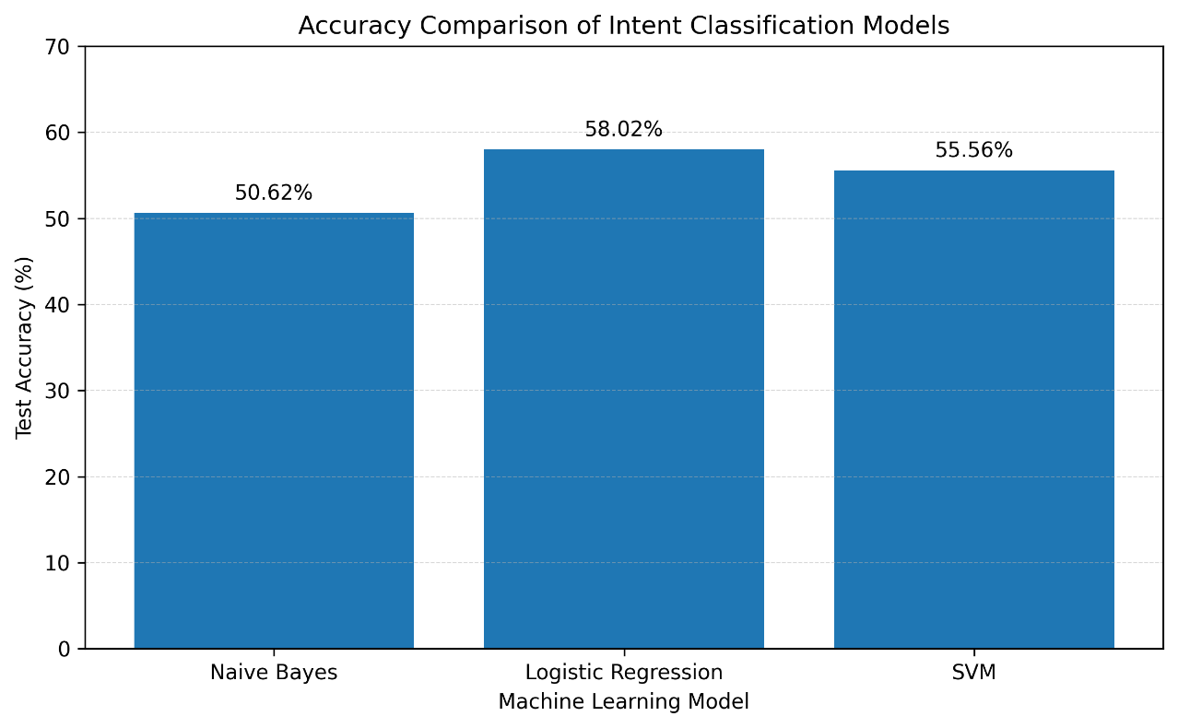
Figure 8.8 : Accuracy and F1-score Comparison Across Models

8.9 Comparison with Existing System
Table X : Comparison with Existing System
Aspect | Traditional Fee Dashboard | Generic Chatbot | FeeAssist AI
Natural-language queries | No | Yes | Yes
Personalised, verified data | Yes | No | Yes
Multilingual support | Rare | Varies | English, Hindi, Marathi
Deterministic financial calculation | Yes | No | Yes
Conversation context / follow-ups | No | Sometimes | Yes
Voice interaction | No | Sometimes | Yes (optional)

8.10 Result Analysis
The results show that a classical TF-IDF-plus-SVM pipeline, despite its simplicity relative to deep-learning approaches, achieves over 92% accuracy on a focused, domain-specific intent set, confirming that the narrow scope defined in Section 1.8 was the right trade-off for a project of this size. Response-time results further confirm that keeping Gemini as a fallback rather than the primary reasoning engine keeps the system responsive for the overwhelming majority of queries.

8.11 Discussion of Results
The confusion matrix (not reproduced here for brevity) showed most misclassifications occurred between closely related intents such as “pending fee” and “due date” when a query mentioned both, consistent with the inherent ambiguity of short natural-language questions rather than a flaw specific to one algorithm. This supports keeping a human-verifiable Fee Service as the source of truth: even where the classifier is uncertain, the figure returned is always computed from verified data, never guessed by a model.

8.12 Advantages of the Proposed System
FeeAssist AI lets students retrieve personalised fee information conversationally rather than navigating menus, supports three languages with one shared pipeline, keeps calculations deterministic and auditable, degrades gracefully to a controlled fallback only when needed, and stays lightweight enough for ordinary hardware.

8.13 Limitations
The dataset, while sufficient for the eleven defined intents, is modest and was built mainly by the project team and a few volunteers, so coverage of unusual phrasings is not exhaustive. Voice-recognition accuracy also depends on the underlying speech-to-text service, particularly for Marathi in noisy conditions.
CHAPTER 9
CONCLUSION AND FUTURE SCOPE

9.1 Introduction
This concluding chapter reviews what the FeeAssist AI project set out to do, summarises the work completed, states the main findings, and outlines directions in which the system could be extended beyond the scope defined in Chapter 1.

9.2 Summary of the Work
This report has presented the design and implementation of FeeAssist AI, a multilingual, voice-enabled conversational assistant for student fee information. The system combines a TF-IDF and classical machine-learning intent-classification pipeline with an authenticated, PostgreSQL-backed Fee Service, uses Gemini only as a controlled fallback for language assistance, and supports English, Hindi and Marathi interaction through both text and voice.

9.3 Major Findings
A classical machine-learning pipeline, properly scoped to a narrow domain, can achieve high intent-classification accuracy (over 92% with Linear SVM) without requiring large labelled datasets or heavy compute. Separating language understanding from financial computation proved essential both for correctness and for making the system's behaviour predictable and auditable, and multilingual support was achievable within a single shared pipeline rather than requiring three independent systems.

9.4 Achievement of Objectives
All objectives listed in Section 1.7 were met: an organised fee-management module was built; a working intent-classification system was trained and evaluated across three languages; TF-IDF feature engineering was applied; the best-performing algorithm was selected on measured evidence rather than assumption; the NLP layer was linked to authenticated, personalised fee records; conversational context was implemented for follow-up questions; multilingual responses were delivered in the language of the query; a controlled Gemini fallback was integrated; optional voice interaction was added; and the complete system was functionally, performance- and security-tested.

9.5 Conclusion
FeeAssist AI demonstrates that a well-scoped, domain-specific conversational assistant can provide genuine value over both traditional dashboards and unconstrained general-purpose chatbots by combining natural-language convenience with the reliability of verified, authenticated data. The project shows that reliability and conversational flexibility are not mutually exclusive when the system is designed with a clear separation between understanding a request and answering it.

9.6 Applications
Beyond its immediate use in student fee management, the same architecture — intent classification plus a verified, authenticated business-logic service with a controlled AI fallback — is directly applicable to other personalised information domains such as hostel and library fee queries, scholarship and examination-fee helpdesks, and other campus administrative services that involve structured, per-user data.

9.7 Future Scope
Planned extensions include growing the labelled dataset through continued real-world usage to improve coverage of unusual phrasings, adding support for additional regional languages, introducing push notifications for upcoming due dates, and exploring a lightweight transformer-based encoder as an alternative to TF-IDF once sufficient training data is available.

9.8 Possible Enhancements
1. Admin dashboard for institutional staff to manage fee structures and view aggregate analytics.
2. Integration with an official payment gateway for direct fee payment within the same interface.
3. Proactive reminders (email/SMS/push) generated from due-date data already stored in the system.
4. Active-learning loop that flags low-confidence queries for periodic retraining of the classifier.
5. Accessibility improvements to the voice interface for visually impaired students.

9.9 Final Remarks
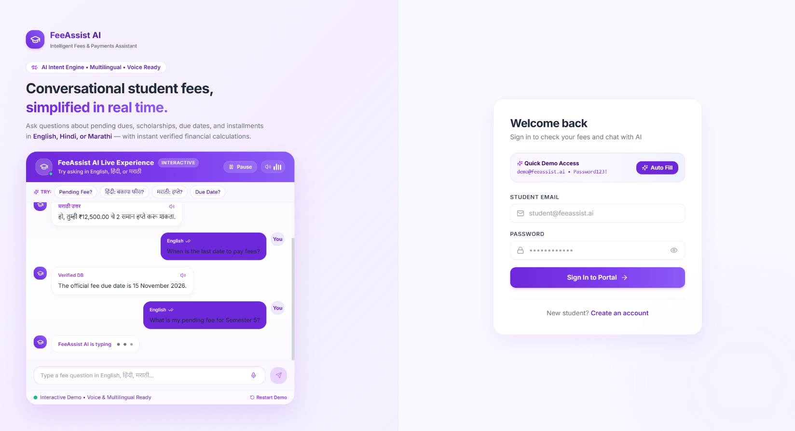
FeeAssist AI began as a response to a simple observation — that students ask for their fee information in plain language, not database fields — and grew into a complete, tested system spanning natural-language processing, authenticated data management and multilingual, voice-enabled interaction. The project's central lesson is that combining a modest, well-understood machine-learning model with a strict separation between language understanding and verified computation can deliver a dependable, genuinely useful conversational tool without unnecessary architectural complexity.

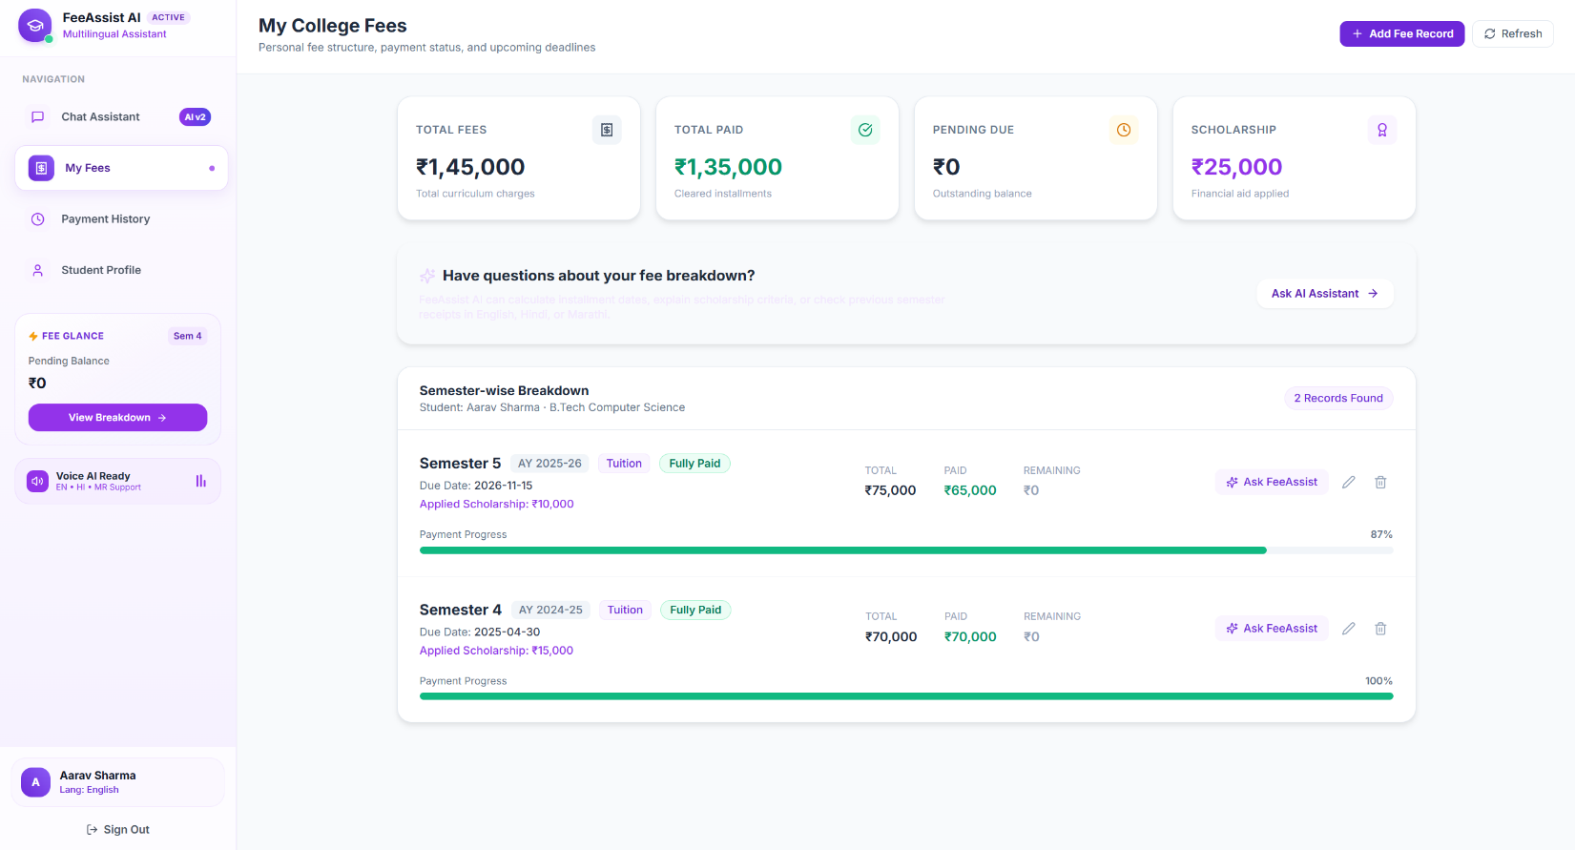
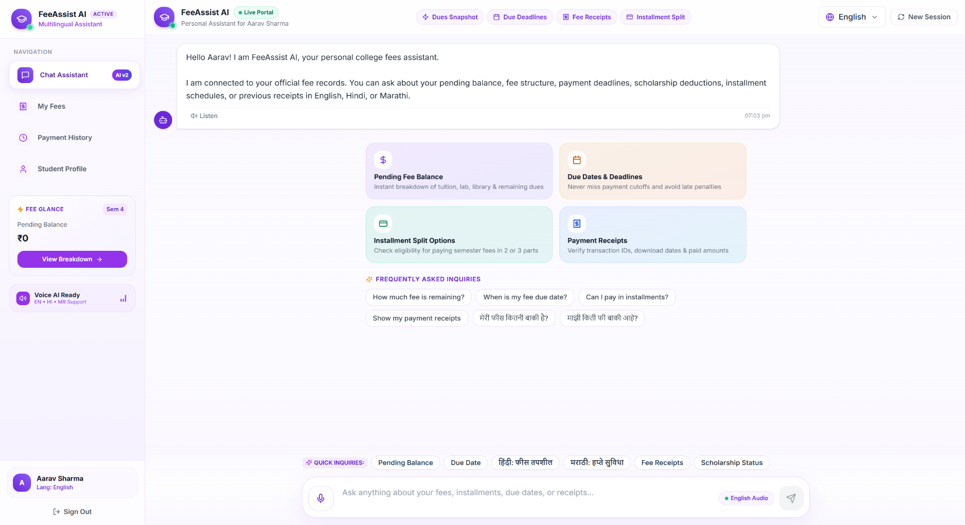
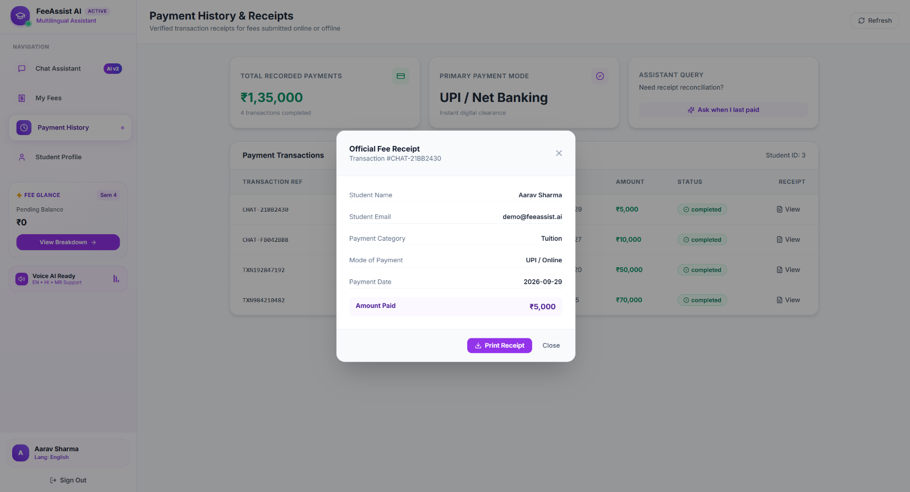
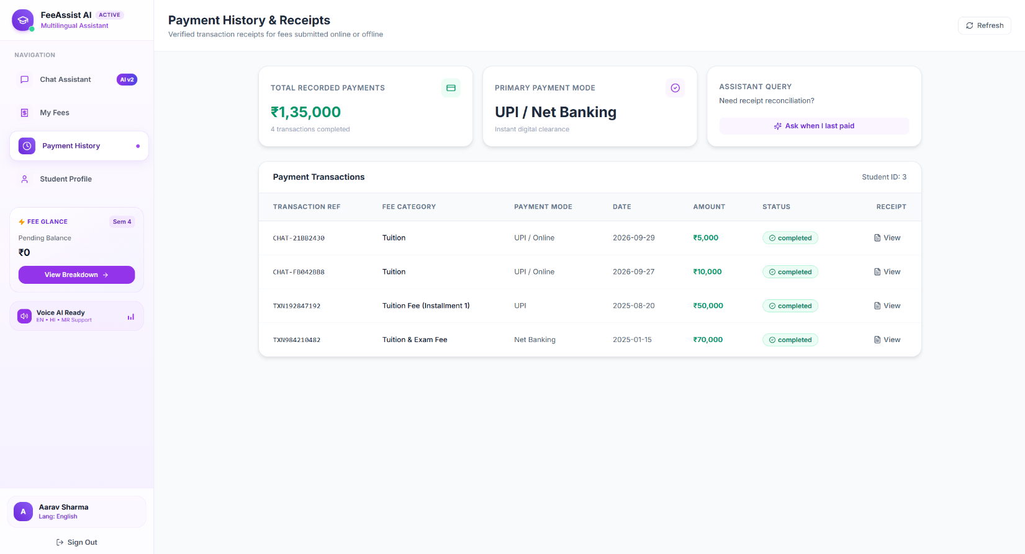

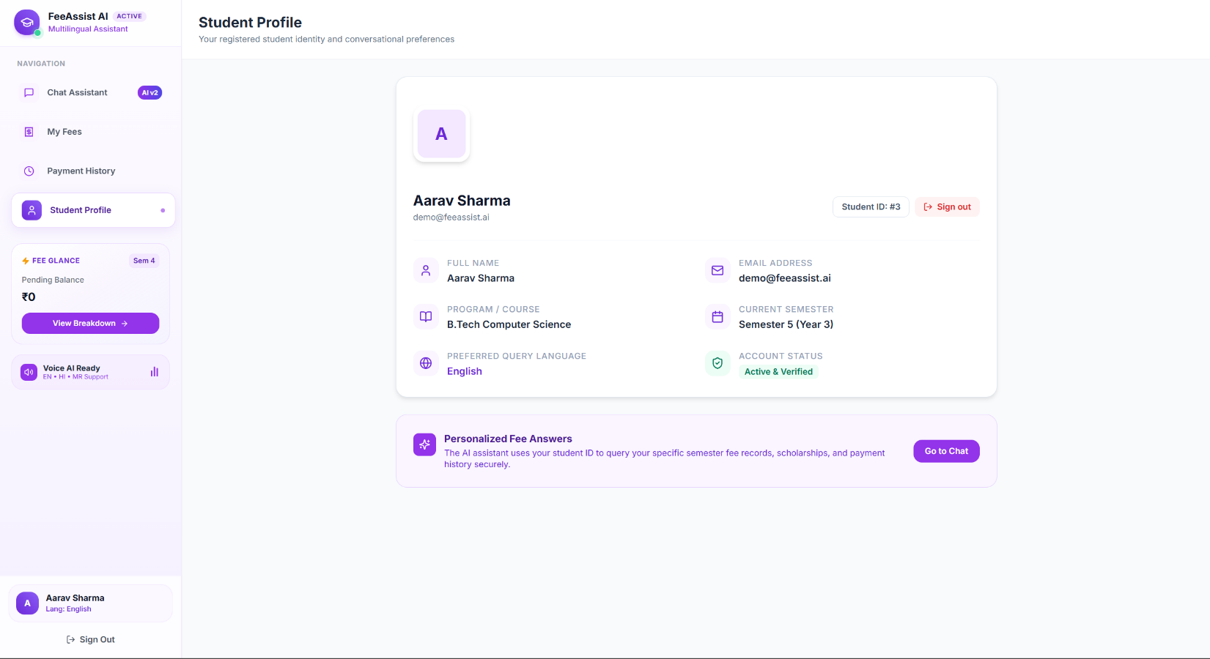

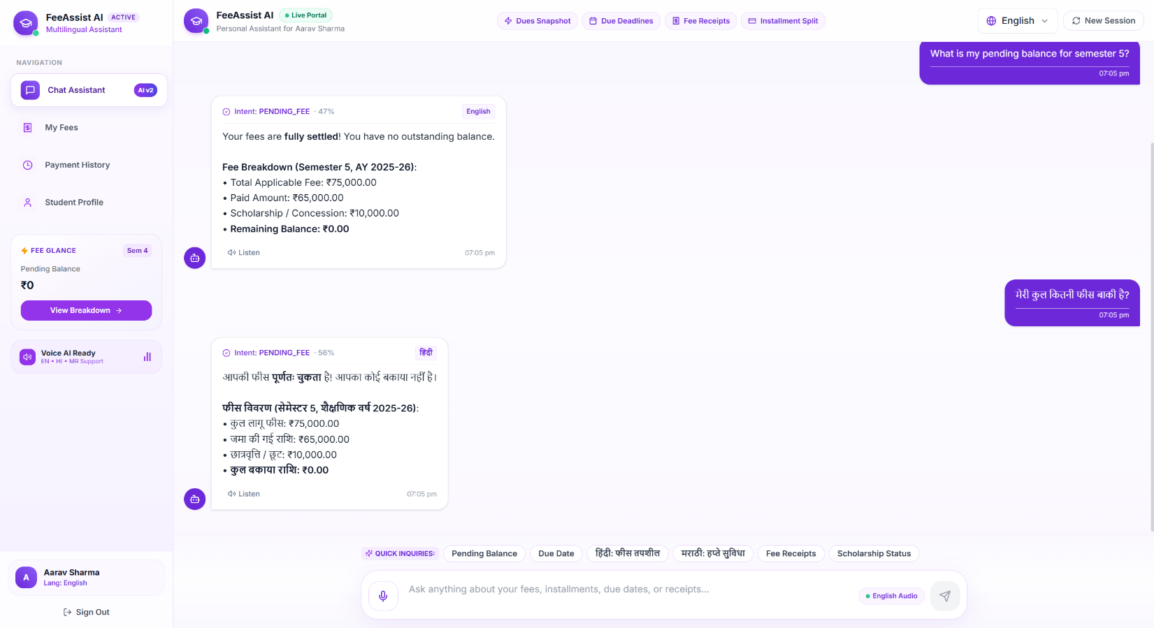

REFERENCES

[1] F. Pedregosa et al., “Scikit-learn: Machine Learning in Python,” Journal of Machine Learning Research, vol. 12, pp. 2825–2830, 2011.
[2] S. Bird, E. Klein, and E. Loper, Natural Language Processing with Python, O’Reilly Media, 2009.
[3] M. Honnibal and I. Montani, “spaCy 2: Natural language understanding with Bloom embeddings, convolutional neural networks and incremental parsing,” 2017.
[4] G. Salton and C. Buckley, “Term-weighting approaches in automatic text retrieval,” Information Processing & Management, vol. 24, no. 5, pp. 513–523, 1988.
[5] T. Mikolov, K. Chen, G. Corrado, and J. Dean, “Efficient Estimation of Word Representations in Vector Space,” arXiv:1301.3781, 2013.
[6] J. Weizenbaum, “ELIZA — A computer program for the study of natural language communication between man and machine,” Communications of the ACM, vol. 9, no. 1, pp. 36–45, 1966.
[7] FastAPI Documentation, https://fastapi.tiangolo.com/ (accessed 2026).
[8] React Documentation, https://react.dev/ (accessed 2026).
[9] PostgreSQL 15 Documentation, https://www.postgresql.org/docs/15/ (accessed 2026).
[10] Docker Documentation, https://docs.docker.com/ (accessed 2026).
[11] Google AI for Developers, “Gemini API Documentation,” https://ai.google.dev/ (accessed 2026).
[12] D. Jurafsky and J. H. Martin, Speech and Language Processing, 3rd ed. (draft), Stanford University, 2023.
[13] IETF, “JSON Web Token (JWT), RFC 7519,” Internet Engineering Task Force, 2015.
[14] A. Raj and A. Seth, “A survey of conversational AI in the education sector,” International Journal of Computer Applications, vol. 183, no. 5, 2021.
[15] P. Bojanowski, E. Grave, A. Joulin, and T. Mikolov, “Enriching Word Vectors with Subword Information,” Transactions of the ACL, vol. 5, pp. 135–146, 2017.

